Wagon Train Sketches and Situations
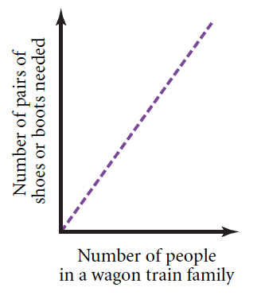
A graph sketch can be used to describe a real situation. For example, this graph sketch shows that the number of pairs of shoes and boots needed for a wagon train family unit depends on the number of people in the family unit.
Your task will be to look at sketches and say what you think is happening. You will also create sketches to represent situations.
Part I: From Sketch to Situation
When you arrive in Fort Laramie, you see posters promoting the journey westward. These posters contain graph sketches describing relationships concerning the trip west.
For each graph, describe what’s happening in the situation that the graph represents. Then answer the specific question for that graph.
- According to this graph sketch, do people on the trail drink the same amount of coffee each day? Explain your answer.
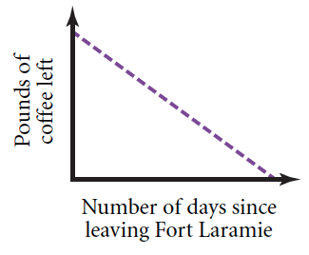
- What do you think is happening at the points on the graph sketch labeled A, B, and C ?
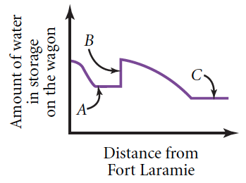
- At what part of this graph sketch was the wagon train moving fastest?
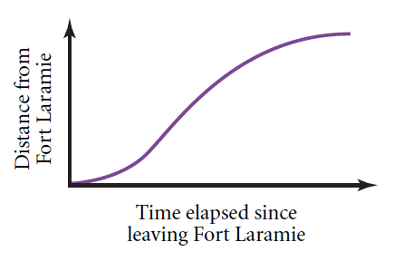
- Why does this graph sketch consist of individual dots instead of a line?
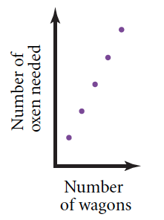
Part II: From Situation to Sketch
Here are several descriptions of relationships. For each description, sketch a graph that illustrates the relationship.
- Wagons of the same size and type can hold a fixed number of people. Make a graph sketch that shows the relationship between the number of wagons (of a fixed size and type) and the number of people those wagons can carry.
- As the number of settlers on the trail increased, the buffalo population declined. Make a graph sketch that shows the relationship between the number of settlers and the buffalo population.
- A man rides his horse from his ranch to a neighboring ranch without stopping. His route takes him through the center of town. Make a graph sketch that shows the relationship between how long he has been riding and his distance from the center of town.

