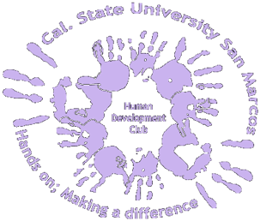

The Human Development Club’s primary goal is to present club members with the opportunity to experience and serve in various fields related to the Human Development Major including: volunteer opportunities, club and non-profit partnership fundraising, and unilateral events with other CSUSM clubs.
We aspire to promote an attitude of community, camaraderie, and service amongst club members, the school, and community.
All currently enrolled students and alumni are welcome to join. Each semester there will be a membership fee of $5. Any special circumstances resulting in your inability to pay the membership fee must be submitted in writing or via e-mail to the club president. Upon the completion of (10) points currently enrolled students will receive a chord upon graduation. All meetings will be (1) point; all events will range from (1-3) points dependent upon the level of participation required. At least (2) points must come from a volunteer event and at least (2) points from participating in a fundraiser. The (10) points must be completed within a two year period. Membership fees must be paid prior to receiving a graduation chord.
For students who have been a member of the club in the past your points will be prorated and if you wish to know the status of your involvement please e-mail the secretary at HDClubCsusm@gmail.com

Please sign and return the form below to the Treasurer along with your membership fee at the next meeting. If you are unable to attend regularly scheduled meeting please place the form in the club’s mail box at Student Life & Leadership in Craven 3400.
Do not drop off any money (cash or checks) the Treasurer will contact you to arrange a meeting to make payment.

HD Club Membership Form

_____________________________ _____________________
Name Student ID#
_____________________________ _____________________
Signature Minor (if applicable)
_____________________________ _____________________
Phone number Email (CSUSM)

