Enough With Rating Professors. Let’s Play 'Rate My Committees.'
August 6, 2014

Besides death and taxes, tenure-track faculty members can count on at least one other certainty in life: committee work.
Some committees can actually be enjoyable and accomplish great things. Others are tedious, boring, and of questionable value, seeming to exist for no other reason than to check off a box on somebody else’s chart.
The younger and less senior you are, the more you’re going to get stuck with the least attractive committee assignments. But as your career progresses, you will have more and more opportunities to choose your committees, within reason. You just won’t be able to choose no committees, at least not until you’re within a few years of retirement.
As a community-college faculty member for 27 years, I’ve had the opportunity to serve on just about every committee imaginable. For those newer to the game, I’ve rated 10 of the most common committees below, on a scale of 1 to 5 (5 being the highest). I’ve based these ratings on three factors: interest (How engaging does the work typically seem?), usefulness (How much does it actually accomplish for the college?), and collegiality (How well do committee members tend to get along?). I’ve also given each an overall rating.
And yes, I did borrow this system rather shamelessly from Rate My Professors. I wanted to go with something more like the American Bandstand rating system of my youth, but unfortunately none of the committees I’ve ever been associated with had much rhythm, nor could you dance to them (with the possible exception of the scholarship committee).
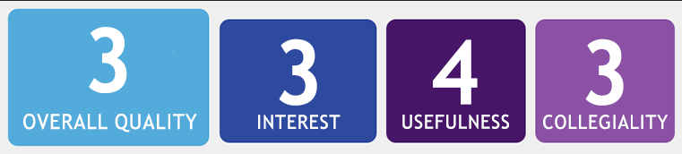
Curriculum Committee
Curriculum committees are both necessary and useful. Not only do faculty members need to work together to determine the curricula for their courses, but it’s one of our major responsibilities under shared governance. The work itself tends to be only moderately boring. And while tempers can occasionally flare, committee members are rarely at each other’s throats in the way they might be if the issue at hand were something really important—like, say, parking.
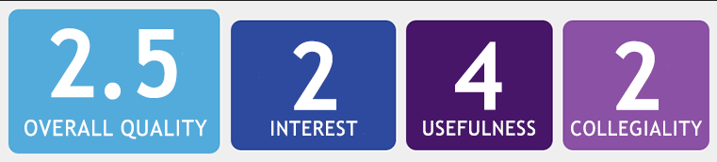
Textbook Committee
Textbook committees are often subgroups of curriculum committees, but the work they do is usually much more boring: Reviewing dozens of possible book choices can give new meaning to the word “tedium.” Still, there’s no denying the need for this sort of work, as long as committee members can get through the process without using desk copies to inflict blunt-force trauma on those who favor a different selection.
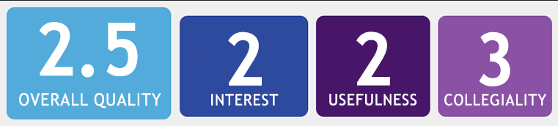
Assessment Committee
Another offshoot of the curriculum committee, the assessment committee actually has two jobs: 1) pleasing people who are screaming for accountability, and 2) actually figuring out how to make individual courses and the overall curriculum better. Not only are these two tasks incompatible, but the former usually takes precedence over the latter. As a result, very little of real value is accomplished, unless you consider getting the accreditors off your back to be of real value, which I suppose it is. At least committee members tend to be relatively collegial. They’re too busy complaining about having to do assessment to spend much time arguing over how it’s done.
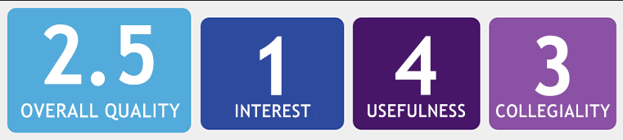
Calendar Committee
This is probably the most mind-numbingly boring committee I’ve ever served on. The work consists largely of trying to figure out what day of the week October 17 will fall on in the year 2026, and how that will affect everything else (and believe me, it does). Nevertheless, the college clearly needs a calendar, and if it’s not set in stone for a minimum of five years out, people start to complain. At least committee members usually get along, empathizing with each other in their collective misery—unless October 17, 2026, happens to be somebody’s parents’ 60th anniversary. Then watch out.
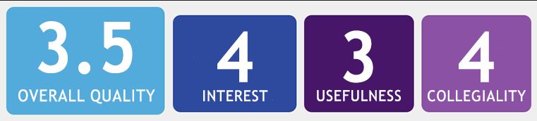
Event-Planning Committee
Event-planning committees tend to be ad hoc, created as necessary to organize and oversee a faculty development day, a visit from a renowned author, or a landmark campus anniversary. Members are usually volunteers who are committed to the event itself, so they find the work rewarding and get along reasonably well, barring minor disputes over venues or tablecloths. “Usefulness” may depend on how the actual event is perceived on campus: Is it something everyone is actually looking forward to or just something the administration is throwing a ton of money at to make itself look good?
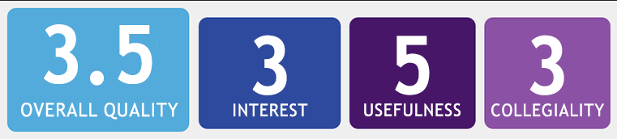
Faculty Search Committee
Finding the best possible new tenure-track faculty members is one of the most important functions of the tenure-track faculty, not to mention another of our key shared governance responsibilities. While the work itself—sifting through all those reams of paper, or poring over online documents until your eyes cross—can be incredibly tedious, it can also be interesting to see other people’s backgrounds. Occasionally, an application even provides a good laugh. Members usually get along just fine, right up to the point where the committee has to narrow the pool from 20 down to six.
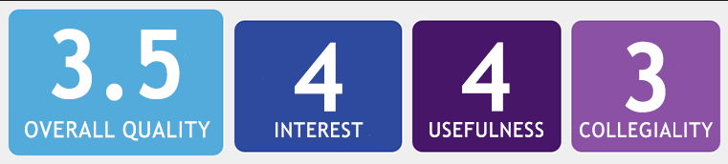
Administrative Search Committee
Finding good administrators is almost as important as finding good faculty, and the work itself tends to be less repetitious—not as many applications to cull through, in most cases. Moreover, the information can be fascinating, especially to the extent that you’re learning things you never knew about your own faculty colleagues who have applied for the job in hopes of fattening their salaries. Just as with faculty searches, committee members can occasionally find themselves in heated disagreements, perhaps exacerbated by friendships, enmities, alliances, and (occasionally) dalliances.
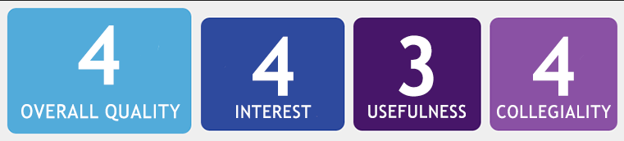
Hospitality/Social Committee

The social committee can be a lot of fun, unless of course you’re by nature inhospitable and antisocial, like me. But the outgoing, people-person types who typically comprise these groups seem to enjoy the experience a great deal, and they all get along famously. (Although there was the Birthday Cake Incident of 2007.) Most would agree that it’s useful to have a standing committee devoted to building department or campus camaraderie, yet sometimes these groups try to make themselves seem more relevant by turning normal functions into social events. (Cake, cookies, and balloons at the exit essay grading session? Really?) But perhaps that’s just my inner curmudgeon speaking.
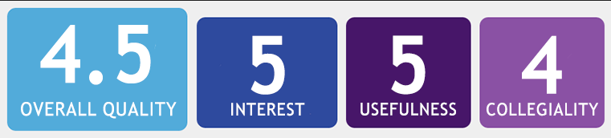
Building Committee
Serving on a committee charged with helping design a new classroom building was one of the most enjoyable committee-related experiences of my career. Members had input on everything from the number and size of the rooms to the décor. (We actually spent an entire meeting comparing carpet samples.) It was fun, all the committee members got along well (although we didn’t all agree on the carpet), and the usefulness of our work was obvious when we toured the completed structure. (Hey, I might be antisocial, but I’ve got a knack for decorating.)
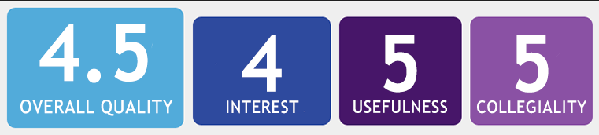
Scholarship Committee
If the building committee was my most enjoyable experience, serving on committees responsible for awarding merit- and need-based scholarships has been, without question, the most rewarding. Sure, sorting through stacks and stacks of applications can be difficult and tedious, but the glimpse that activity affords into our students’ lives is priceless. Members might have differing opinions—might even become animated when arguing the merits of their favorite candidates—but at the end of the day we’re all there for the same purpose: to serve our students and help them succeed. Isn’t that what it’s all about?
♦ ♦ ♦
If I’ve left off your favorite—or least favorite—committee, please feel free to add it below, along with ratings and a comment. And if it was an especially “hot” assignment, you can indicate as much by creating your own emoticon chili pepper. Just hit the less than sign, followed by the equal sign and then an apostrophe.


Rob Jenkins is an associate professor of English at Georgia Perimeter College.
- See more at: https://chroniclevitae.com/news/645-enough-with-rating-professors-let-s-play-rate-my-committees#sthash.Xtmi760O.dpuf

