Doing Scholarship from Outside Academe

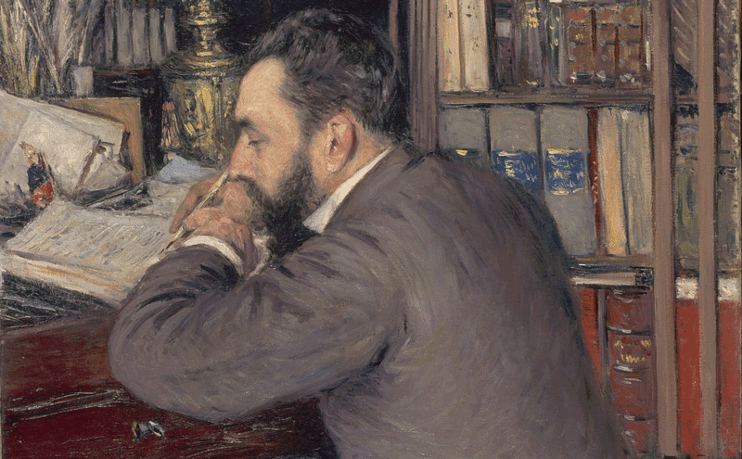
December 4, 2014
Image: Henri Cordier, by Gustave Caillebotte, 1883 (Google Art Project)
I am a historian of science, but I make my living as a publishing consultant. Does that make me an independent scholar, a “#postac,” or some sort of hobbyist?
Those issues are on my mind because of a careers panel I recently participated in at the annual meeting of the History of Science Society (HSS). My assigned task was to inject a dose of reality into discussions of what it’s like to do research and write scholarship without a tenure-track job. I offered my own story as a cautionary tale: During the seven years that I had what most people think of as a “regular job” (that is, a salaried position), I didn’t publish a single thing that might be considered original scholarship. For me, research and writing required the freedom and flexibility that only came when I quit to pursue self-employment. That had less to do with any of my employers’ specific policies than with the structural constraints of time, resources, and position.
Telling my story at the HSS meeting did not strike me as particularly controversial. I was surprised, then, when multiple people in the room took offense after I referred to my writing as “my own work,” instead of calling it “scholarship.” Apparently by calling it “my own work,” the criticism went, I was unintentionally reinforcing the notion that only traditional, peer-reviewed publications count as scholarship. After all, in my previous positions, I had edited and written for a general-interest magazine on the history of science, produced podcasts, and hobnobbed with research fellows—and all in my own field, to boot! Surely all of that “counted” as scholarship.
The history of science is a field obsessed with how historical actors have come to claim expertise. So we are more sensitive than most to the ways in which disciplinary labels establish hierarchies. Over the past five years, the HSS has held a series of panel workshops on postacademic life. The goal was to explore how archivists, curators, publishers, producers, grants officers, and policy analysts can put their disciplinary expertise to work in the world outside academia. If one of the lessons of ”Quit Lit” is that Ph.D.’s stay in miserable, contingent situations because they can’t envision alternatives, the HSS—along with a growing number of learned societies and of course Vitae itself—is doing its part to make viable career alternatives more visible. (Full disclosure: I was recently elected to the society’s governing council.)
Having held some alternative jobs myself, I’m all for destigmatizing the work of Ph.D.’s who decide they’ve had enough with the contemporary university’s meager employment options. But as the panel discussion continued, I became more and more uncomfortable as participants labeled the wide variety of professional activities carried out by Ph.D.’s in nonacademic jobs as “scholarship.”
Some Ph.D.’s who reject (or are rejected by) the tenure track end up in careers where they are genuinely involved in producing and disseminating knowledge. But others end up in management consulting, administration, or public relations. A recent study conducted on behalf of the American Historical Association found that, of the quarter of history Ph.D.’s who do something other than teach at a college or university, nearly 40 percent worked in business, in publishing, as contract researchers, or were otherwise self-employed. In today’s economy, people with Ph.D.’s end up doing just about everything, including repairing motorcycles and stripping.
Not all of those things are scholarship. Genuinely embracing the idea of life beyond the professoriate means accepting that some people, having obtained a Ph.D., would prefer to wash their hands of the whole thing. Those people don’t need to redefine their nonacademic work as “scholarship.”
But there’s another danger here, one that has continued to nag at me ever since that panel. If some of us gleefully toss our scholarly training to the winds, others hold it close. Some of us who obtained advanced graduate training did so precisely because we wanted to deeply and seriously engage with certain topics as writers. That desire didn't necessarily vanish when we accepted nonacademic jobs, even if those jobs had some direct relationship to our field. We might be getting paid to do something resembling, say, history, but are plagued by a sense that it’s not-quite-history. Telling #postacs that their nonacademic jobs are still “scholarship” is another way of silencing expressions of loss. It’s tone policing, and it has no place in honest discussions of what it means to walk away from an academic career.
This everything-is-scholarship talk eliminates the need to acknowledge, let alone deal with, the barriers to producing well-regarded scholarship from outside the academy. While it’s possible to pull it off, it’s not easy, and you should stop listening—immediately—to anyone who says otherwise. Aside from the obvious issues of time, money, and lack of academic affiliation, Ph.D.’s who end up in either nonprofit institutions or corporations may have to negotiate intellectual-property agreements or conflict-of-interest statements with their employers. To give an obvious example: If you work in development for a major museum, you can’t publish on the topic of how fund raising shapes exhibits. You just can’t, or at least, you shouldn’t, not if you’d like to continue in a career in the museum world. And if you did somehow manage to pull that off, your readers would nevertheless question your motives.
When you work for a nonacademic employer, your time and your words are not necessarily your own. Traditionally, the conventions of academic freedom—however flimsy—have granted some protection to scholars producing work within the academy. No such rules apply to Ph.D.'s working outside higher education. For me, it took quitting my job and launching my own consulting business to find the time, energy, and flexibility necessary to carve out space for traditional scholarship (i.e., peer-reviewed articles and a scholarly book). Consulting, freelancing, and other forms of self-employment aren’t for everyone, but for opinionated people desperate to find a path back to writing, they’re options worth exploring.
I work with scholars for a living in my consulting business, but I don’t confuse those paid services with my scholarship. The latter is something I do on my own time. And no one’s going to tell me it’s not mine.

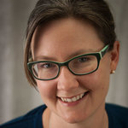
Audra Wolfe is an editor, writer, and historian based in Philadelphia.
She holds a Ph.D. from the University of Pennsylvania and is the author of Competing with the Soviets: Science, Technology, and the State in Cold War America (Hopkins, 2013).
- See more at: https://chroniclevitae.com/news/824-doing-scholarship-from-outside-academe#sthash.25qxajNk.dpuf

