How Long Can You Rely on Your Dissertation Adviser?
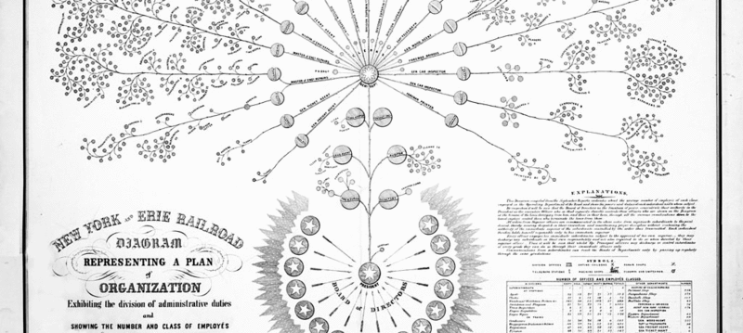
November 14, 2014
Image: Organizational diagram of the New York and Erie Railroad, 1855, by Daniel McCallum & George Holt Henshaw
As you wrote your dissertation and searched for your first faculty job, your dissertation adviser was (I hope) there for you. He read countless drafts of your chapters. She helped you get published. He wrote scores of letters on your behalf. She may have even made phone calls for you. Now that you’re no longer a doctoral student, your adviser still may be the person who knows you best.
But how long can you keep turning to the same person to write you a letter of recommendation?
There is no definitive answer to that question. The good news is you can probably rely on your adviser until you’ve developed a new network of recommenders who don’t see you, first and foremost, as their student. The bad news is, at some point after completing the Ph.D., you’ll need to step out of your comfort zone and cultivate a network of people -- beyond your former professors -- who can write letters on your behalf. The sooner you cultivate that network, the better. It doesn’t need to happen in your first year on the tenure track, but it should happen before you submit your tenure application.
So where do you find these letter-writers?
The first place to look is in your new department. Start by fostering a letter-writing relationship with the department chair, who likely will have to write something on your behalf at some point anyway.
Next look for a departmental colleague whose research interests are close to your own. Believe it or not, you also may end up writing letters for that person, too. So while you’re reaching out to that colleague for advice on your own work, familiarize yourself with his or her work, too. The more familiar you both are with each other’s work, the more useful your mutual feedback and letters of recommendation will be.
Finally, try to connect with a faculty member in your department who is particularly interested in pedagogy, so that person can write teaching-related letters on your behalf. Talk to each other about teaching. Ask for advice on how to succeed in your university’s teaching-evaluation process. In my previous position, for example, we were required to have peer reviews of our teaching each year and the person who conducted the review had to write a letter to the chair evaluating us in the classroom. By the time I went up for tenure, I had five of these letters to include in my tenure case.
You will need letters from colleagues for a variety of purposes, including internal grant competitions, teaching awards, and future job applications. So now is the time to think about who in your new department might write letters for you.
The second place to look for recommenders is within your field. If your institution requires external letters for tenure review, it’s in your interest to build a list of a dozen senior scholars who have a favorable opinion of your work. The very idea of approaching the bigwigs in your field sounds frightening to a junior scholar, but, trust me, you’ll need that list of names when you go up for tenure. Here’s why: Most institutions let you pick some of your external reviewers, so you’ll want to have a clear idea about whom to suggest.
Start making that list now. Take out a sheet of paper and write down the names of the 12 people you most admire in your field. Don’t contact all of them immediately. But do start thinking of ways to reach out to them over time.
Pick the one that seems most approachable and ask him or her to have coffee with you at the next conference. Send a copy of your latest publication to the one whose work you recently cited. When your department is discussing whom to invite to the next colloquium series, suggest someone on your list whose work you think has the broadest appeal. One of my most well-known letter-writers is a person my department invited to campus to deliver a public lecture. If you are organizing a panel at a major conference, ask one or two of these senior scholars to participate as a panelist, chair, or discussant. If you edit a special issue of a journal, invite them to contribute.
There are many ways to reach out to scholars in your field. Once you have done so and developed a relationship with them, you can ask them to write you a letter of recommendation -- for a job, for an award, or for a fellowship.
Start building these essential relationships now and, eventually, you will be able to stop asking your dissertation adviser to write you yet another letter.
Tanya Golash-Boza is an associate professor at University of California at Merced.
- See more at: https://chroniclevitae.com/news/799-how-long-can-you-rely-on-your-dissertation-adviser?cid=VTEVPMSED1#sthash.bRqzfcp1.dpuf

