Black Bean Soup
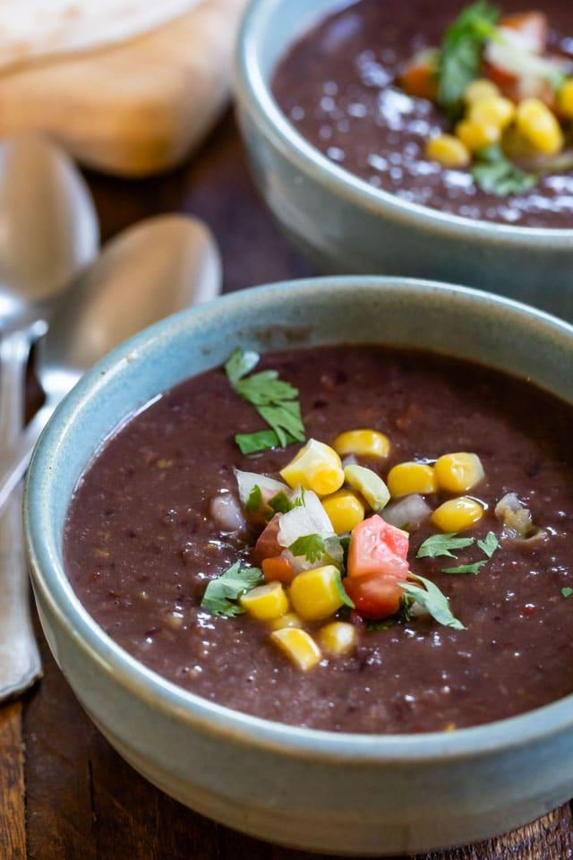
Prep time: 10 minutes
Cook time: 40 minutes
Servings: 6
Ingredients:
- 2 cans black beans
- 1 cup of corn
- 3 cups of chicken or vegetable stock
- ½ teaspoon salt
- ½ teaspoon pepper
- 1 tablespoon olive oil
Optional Ingredients (not typically offered at cougar pantry, but may help enhance flavor):
- 1 medium onion finely, chopped
- 1 medium red pepper, finely chopped
- 1 jalapeno, finely chopped (seeds removed)
- 4 cloves of garlic, minced
- 2 teaspoons cumin
Directions:
- Add oil to a pot and set the stove to medium heat.
- Add onion, red pepper, and jalapeno and cook for about 10 minutes (until vegetables are soft). Stir in garlic for one minute. (if applicable)
- Add the black beans (with the liquid in the cans), chicken or vegetable stock, salt, pepper, and cumin. Stir and cover. Bring to a boil and cook 15-20 minutes. Once the soup is cooked, add the corn for 1 additional minute (or until corn is warm).
- Serve with additional salt and pepper to taste.

This wholesome and nutritious bean soup is perfect to eat for lunch or dinner. It is filled with proteins and carbohydrates derived from plants. This meal is also very fibrous, which aids in healthy digestion. Beans have calcium, potassium, and magnesium, as well as having low sodium levels naturally, which can help lower blood pressure. To enhance the flavor, top with cheese, sour cream, tortilla chips/strips, and/or or fresh herbs like parsley or cilantro, if desired. You may also use toast, bread rolls, or crackers to dip. Recipe adapted from: https://www.crazyforcrust.com/black-bean-soup/

