Syllabus Design for Dummies
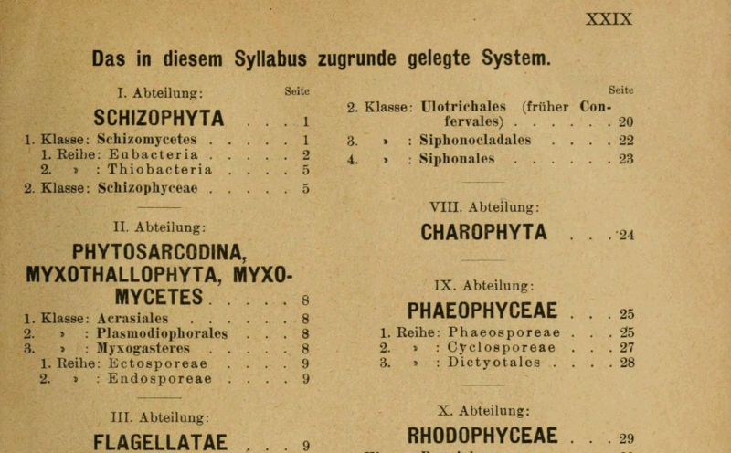
October 19, 2014
Image: Page XXIX of Adolf Engler's Syllabus der Pflanzenfamilien, ed. 8, 1919
I know plenty of teachers who dread writing their syllabi, putting them off until the last minute when, finally, the night before classes start, they quickly crank out just enough to make it look like they know what they’re doing. Don’t do that. You will be much better off if you allow some time to think about the syllabus before writing it. A syllabus should go through multiple drafts before it’s shared with students.
Since a large portion of Vitae readers are graduate students and early career professors, we decided to put together an introductory guide to syllabus design. I always enjoyed the course design part of teaching, so I want to share the best course prep strategies I picked up as a teacher of freshman composition. See what you think and then use the Teaching Tips group to continue the discussion.
Designing Your First Syllabus
The good news is: Once you have a basic outline for your syllabus, you can reuse most of it each semester. Once you get the language worked out in key sections, you really won’t need to alter it much--only a few minor changes here and there as you begin to find your classroom persona and learn what works and what doesn’t.
Fortunately, you can already find some syllabi online. A quick Google search will turn up dozens of hits in your field. And here’s some more good news. To make it even easier to find syllabi that are relevant to you, we’re building a database. It’s new—so new, in fact, that you won't see more than a few syllabi in there yet—but the idea is to let professors share their materials and pay it forward for the next person.
So we hope you’ll join us in this experiment. Wouldn’t it be great to pool your materials and take advantage of the knowledge base that has come before you, instead of trying to reinvent the wheel? Those existing resources will likely be your best tools as you design your own syllabus.
The Sections
Your syllabus should be divided into a couple of different sections. It might help to draft the document in phases, writing it one section at a time.
Think about the syllabi your professors used. Get a couple of them out and look them over. What major sections do you see? What do you like about them? What do you dislike? What ideas might you be inclined to borrow?
Writing in sections can be particularly helpful to first-time teachers. My basic syllabus for Composition II was divided into four major sections:
- Expectations and Objectives
- Assignments and Grading
- Policies and Procedures
- Course Schedule
Each section had important information for my students. I tried not to include any unnecessary or redundant details. I’ve seen syllabi that are 10 pages long, but personally I didn’t go for that style. I wanted my students to actually read my syllabus and understand it, so I trimmed it down to what I viewed as the absolute essentials.
1. Expectations and Objectives
This first section of the syllabus is a brief introduction to your course. It tells students what they’ve gotten themselves into by signing up for the class.
At the top of the page, list all necessary contact information. I preferred that students communicated with me via email and I left my office hours open to appointment. Some universities will require that specific office hours be stated on the syllabus, but I always explained to my students that I was in my office often during the week and all they needed to do was send me an email so I could make sure I didn’t miss them.
Most colleges require professors to spend at least an hour a week in the office for every section taught. You’ll probably be there more frequently–especially during your first few years as a teacher. It usually worked well for me to arrive at the office an hour before class and stay an hour afterward. Those are the times most students want to meet.
This first section should also name the required texts for your course. List every book students need to buy. Be aware that, when it comes to freshman survey courses, the campus bookstore will probably not create shelf space for each faculty member teaching a section of that survey course. If you plan to use readings other than the standard texts, you’ll want to make that clear to students on your syllabus.
Some of the texts I listed were required and some were optional. I made key readings from expensive texts available online, and I left it up to students to decide if they wanted to buy a hard copy. Always pay attention to copyright rules when making texts available online. A university librarian can help you with that.
My “Expectations and Objectives” section underwent many changes and revisions over the years. Here are a few questions to ask as you craft your own: What do you want your students to learn? What outcomes do you hope the course achieves? Do you have any definitive rules that are non-negotiable in your classroom? The bottom line here is: What will your students have accomplished by the end of the semester and how will they accomplish it?
It’s also smart to mention in this top section any unusual requests or policies you have. For example, I had a paragraph about collaborative learning in this section because we did a lot of group work. I wanted students to know on the first day of class what would be expected of them. If they weren’t down with the “decentered” learning model, then they wouldn’t like my class. Some students dropped after learning this on the first day.
If you have any other special information to declare, do it here as well. Will students be keeping a daily journal? Do you require multiple class presentations? Anything that might surprise a student later in the semester should be addressed here. It’ll save you a headache later. Also be sure to mention the importance of this first section when you go over the syllabus.
2. Assignments and Grading
Make it very clear how each student’s final grade will be determined. Any chance you get to detail your grading process is important. At some point, you will have students who appeal their grade and you will need to justify yourself. Everything will be fine as long as you can prove that a student knew the grading process and that you awarded the grade based on a calculated system.
List every assignment in this section and show the percentage breakdown for the final course grade. What will students be expected to do? Will they turn in assignments daily? Weekly? Is participation important?
As you determine your grading breakdown, always keep in mind your personal workload–especially if you are teaching more than two sections. Daily journal entries might sound good in theory, but multiply that by 100 students and it gets pretty crazy. I don’t recommend doing that to yourself.
3. Policies and Procedures
The policies and procedures section is required by most departments. You will likely have boilerplate language that your department or institution will require you to include here. I won’t dwell on this section, but be sure to point out any important departmental policies. Is there a strict attendance policy? Any add/drop dates that should be emphasized?
When I taught at the University of Georgia, the composition department had a strict attendance policy and I loved it. If your college does not have a firm attendance policy, consider developing one of your own. More than four absences and the student earns a zero in participation would be a good place to start. Unfortunately, attendance is a big problem now, so plan accordingly.
4. Course Schedule
The fourth section of the syllabus is devoted to the schedule. Simply list every day of class and state explicitly what will be due on each of those days. I found it was much easier to plan the entire schedule in advance than to try and make up assignments on the go. Putting the schedule in writing is also more practical for students who miss class--they can just check the syllabus. Otherwise you will end up having to explain the assignment over and over again by email.
A Few Final Words of Advice
These four sections of your syllabus will evolve over time. Use trial-and-error to determine what works best and weed out unnecessary language and failed assignments. Your first few teaching years will undoubtedly include a good bit of culling. If they don’t, then you probably aren’t monitoring your process well enough. In order to grow as teachers, we should continually try new things and cut mediocre strategies.
A couple of final things to consider as you prepare your first syllabus:
- Will you read the entire syllabus on the first day? I strongly recommend that you do. That way students can’t claim they weren’t aware of your attendance policy or the group work that you require.
- Will you hand out a hard copy of the syllabus or will you go all digital? On the first day, I liked to give each student a hard copy that we could go over as a class. Any duplicate copies or revised copies had to be printed by the student or accessed online. I always kept a digital copy available to students for downloading.
- How will you handle revisions to the syllabus? Chances are your course schedule will need to be updated later in the semester if you get behind or make changes based on student response. I usually went over revisions in class and then told students to print a new copy of the revised syllabus on their own.
- Remember: Your syllabus is a work in progress. You will almost certainly revise it every semester. Do your best on this first one and make adjustments. Take notes in the margin during the semester so you remember what works and what doesn’t.
Now what about you? What advice would you give to first-time syllabus designers? What questions do you have? Check out this discussion thread in the Teaching Tips group for more information.
Josh Boldt is a writer, editor, website builder, app designer, vintage furniture dealer, backpacker, and recovering adjunct professor.
- See more at: https://chroniclevitae.com/news/754-syllabus-design-for-dummies?cid=chearticlepromo#sthash.Ejq9plos.dpuf

