A Corral Variation
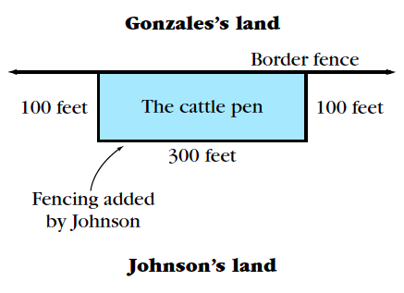
Dairyman Johnson raises cattle. There is a long, straight fence along the border between his property and that of his neighbor, rancher Gonzales.
Dairyman Johnson likes rectangles, and he also values efficiency. He realizes that the fence between his property and that of rancher Gonzales can serve as part of a fenced-in pen for some of his cattle.
His plan is to use part of this existing fence along the border as one side of a rectangular pen and to build the other three sides using 500 feet of fencing he has purchased. For example, he might build the pen so it looks like the diagram at the right.
- What is the area of the cattle pen shown in the diagram?
- Choose three other possibilities for the dimensions of the rectangular pen, and find the area for each pen you create. Keep in mind that dairyman Johnson can use as much or as little of the existing fence as he likes and that he wants to use a total of 500 feet of fencing for the other three sides.
- Suppose the pen extends x feet away from the existing fence along the border. (For example, in the diagram, x would be 100 feet.) Find an expression for the area in terms of x.
- Try to determine the value of x that will maximize this area.

