How to Tailor Your Online Image
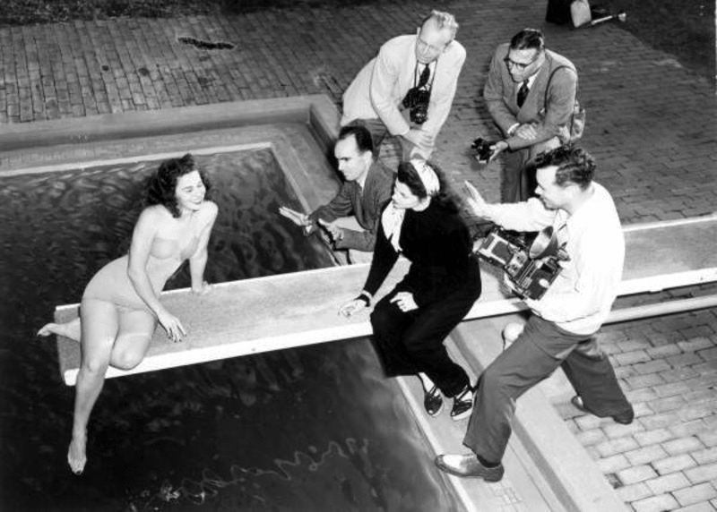
June 8, 2015
Image: FN&PS photographer ready to take pictures for a model on location: Ponte Vedra Beach, Florida, 1946 (State Library and Archives of Florida)
What should I do about social media and an Internet presence, while I’m on the job market?
I am asked this question constantly and I’m glad, because every job seeker should be asking this question and thinking hard about the answer. I could write a book on the subject of academic uses and abuses of Twitter and other social media at this point, and I’m sure that somewhere somebody is, because the issue has never been more fraught. But for the sake of this column, I’ll be brief.
You should have a curated Internet presence for the job market. The fact is, you will be Googled. That is not usually because search committees are trying to dig up dirt on you, or derail your candidacy. Rather, they just want to know more about you, and get a sense of your intellectual communities, of where and how you are active, and of your “style” of communication (lively, reserved, direct, blunt, tactful, supportive, combative, and so on).
So be aware that your Internet footprint will be examined. And be proactive in getting out in front of it, so that you know — and control, to the extent you can — what viewers will see. First off, search for your name (on a variety of different search engines, perhaps using several different search strings attached to your name). Then take steps to deal with what you find.
The most important thing you can do is establish a personal academic website. Even if you have no coding knowledge, you can design it yourself using any of the virtually countless website design programs available. Just search for “drag and drop website design” and explore your options. Read this Vitae post by Kelli Marshall on managing your digital identity for some recommendations. You can also use the simple options at Academia.edu or Vitae.
Your personal website should contain a relatively “serious” photo of you looking “professional” (i.e., dressed for work, or perhaps in the classroom, lab, or field), plus a concise summary of your research, a link to your CV, links to your articles and conference papers, perhaps some teaching material, and so on. Your site doesn’t have to be complicated. It also doesn’t have to include a blog — if you want to blog you can, but it’s not required, and be aware that a rich blogging history but little-to-no record of traditional peer-reviewed publications makes you look like a very poor risk for tenure.
Your goal here is a curated Internet presence that frames your profile in a concise and clear way, and gives search committees a focal point for their searching. You have an internet presence. You cannot avoid that. Your task is to manage it.
Now, on the question of social media such as Facebook and Twitter, my advice is more equivocal. I firmly believe that all academics should engage on social media. So, OK, I guess that’s pretty unequivocal.
But how you engage, as of 2015, requires some very serious and rather depressing calculation. The fact is, in a post-Steven Salaita and post-Saida Grundy world, no academic -- whether senior or junior -- can afford to post candid and controversial ideas on social media without fear of surveillance and possible professional repercussions. Institutions are not showing evidence of protecting the academic freedom of students or faculty in social-media settings.
In light of that, why do I state so unequivocally that academics should still engage on social media?
Because I believe the potential gains outweigh the potential risks, as long as users either: (a) Stay firmly on the side of the collegial and noncontroversial, and use social media to engage with their networks around topics that cannot be misconstrued by upper administration; or (b) continue to be bold and critical in their social-media activity, but clearly understand the grave risks attached.
Many scholars, including myself, are engaged daily in dynamic, energetic, and constructive dialogues on Facebook and Twitter on a host of topics related to scholarship, teaching, organizing, and social critique. These dialogues are a central element of our professional identities and trajectories. Our careers are unthinkable without them. Do not deprive yourself of those opportunities -- which absolutely can lead from virtual to face-to-face engagement and invitations -- out of fear, or even an excess of caution. Many readers and clients tell me they are inclined to avoid social media, and that’s a mistake. Certainly you can’t assume you can write anything you want without any possibility of professional harm. You just need to be careful.
I want to make myself perfectly clear: I deplore that I am telling readers (who are mostly vulnerable junior scholars) that they should probably censor themselves on social media. This is a terrible state of affairs, and part of the overall assault on academic freedom, tenure, and the entire edifice of higher education in the United States. As a former professor, and someone who loves the potential of academia to shine a critical light on the structures and abuses of power in society, it breaks my heart. But I am choosing to be this frank about the risks that I see so that, ironically, I can encourage young scholars not to give up on social media entirely. Because I believe that is throwing the baby out with the bathwater.
I will not devolve here into a list of topics I deem safe versus unsafe. I have enough respect for readers to trust that you can make these deliberations yourself, in consultation with your professors and peers, and in light of your own institutional and disciplinary contexts. I simply want to be explicit that I believe activity on social media is essential to career-building at this point in time, despite the chilled environment around it, and it yields gratifying virtual and real-life communities and opportunities.
It can even lead — somewhat indirectly —to a job offer. I’ve seen that happen. So proceed onward with your website and your social media, but do so with care and consideration.
Karen Kelsky is a career consultant who runs the website The Professor Is In. She’s been a tenured professor at two public universities (Oregon and Illinois) and has advised many undergraduate and graduate students, as well as mentored junior faculty. She answers reader questions as a contributor to Vitae.
For more advice, pre-order Dr. Karen's new book, The Professor Is In: The Essential Guide to Turning Your Ph.D. Into a Job. Available for pre-order now; comes out August 4.
- See more at: https://chroniclevitae.com/news/1027-how-to-tailor-your-online-image?cid=VTEVPMSED1#sthash.whbAvCPM.dpuf

