Sports nutrition tips to keep your athletic performance top-notch
What you eat and drink is just as important as how hard you train when it comes to sports performance. Maintaining a program for sports nutrition helps you perform your best and grow stronger.
Specific requirements of nutrients vary based on your size sport and how often you participate. Consulting with a nutritionist or sports dietitian is the best way to develop a tailored plan for your needs and activity however all programs include some basics.
Balance macronutrients
“Macronutrients” refers to the big three components of food: fat carbohydrates and protein. Everyone should keep fats limited and aim to eat more unsaturated fats than saturated. Opt for nuts unrefined oils seeds and lean meats like chicken or fish.
Carbohydrates are what give you energy and protein helps repair and build muscle. It’s a myth that all athletes should follow a high-protein low-carb diet. Your muscles need stored glucose provided by carbs to maintain energy and athletic performance. How much carbs and protein you need varies by your sport. Athletes in endurance sports need more carbohydrates for sustained energy and a modest level of protein. Athletes in power sports need more protein and a moderate amount of carbs.
Protein is one of the main nutrients you hear about when it comes to sports — but that doesn’t mean you should guzzle a protein shake for every meal. The Academy of Nutrition and Dietetics reports that many nutrition experts say athletes should consume 1.2 to 2 grams of protein per kilogram (roughly .55 to .9 grams per pound) of body weight every day. Protein intake should be spread throughout the day and can come from plant and animal sources. The International Olympic Committee recommends that athletes consume 15 to 25 grams of protein within two hours after a training session for the best results and muscle repair.
Eat a well-balanced meal three to four hours before training or a match. Choose whole grains combined with protein and moderate fat. Sweet potatoes provide great fuel for a workout. Grilled chicken salad with fruit and dark leafy greens is a good recovery option.
Mix in micronutrients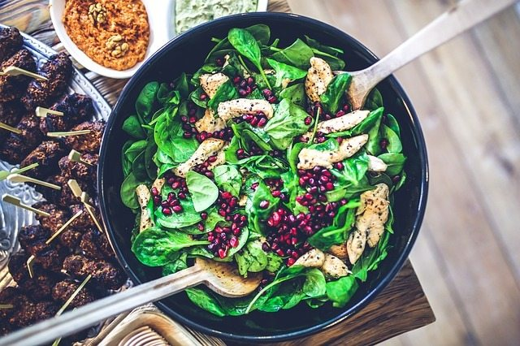
Micronutrients refers to all the other vitamins and minerals you need. Athletes should make sure they get plenty of calcium and vitamin D along with iron B vitamins zinc and magnesium.
Bring it all together
You can get adequate sports nutrition through diet alone. Sometimes supplements or shakes are helpful when you’re pressed for time but eating whole foods is always best. Keep these tips in mind when planning your balanced diet:
- For macronutrients choose lean meat whole grains and lots of fruits and vegetables. You don’t have to eat meat to fulfill your protein needs. Many top athletes are vegetarian or follow a plant-based diet.
- Eat plenty of fruits and vegetables. These provide you with micronutrients antioxidants and carbs. Keep red meat limited and opt for low-fat dairy products.
- Some great foods for fuel include oatmeal, low-fat yogurt, nuts, bananas, salmon, eggs, oranges and flaxseed. Try combining these ingredients in meals and snacks.
Wash it down
What you drink is also important. Drinking water throughout the day is the best way to stay hydrated. Sports drinks can be helpful in replenishing electrolytes and carbs lost during exercise but the American Council on Exercise lists out some foods that contain the same nutrients. If you sweat a lot during play look for drinks that provide salt and potassium.
Training hard requires you to have a well-planned diet to make sure your food is meeting your body’s needs for energy and recovery. A nutritionist can provide tailored guidance to your sport and eating preferences to help you achieve the best performance.

Information taken from; https://www.reidhealth.org/blog/sports-nutrition-tips-to-keep-your-athletic-performance-top-notch

