The Confidence Gap in Academic Writing

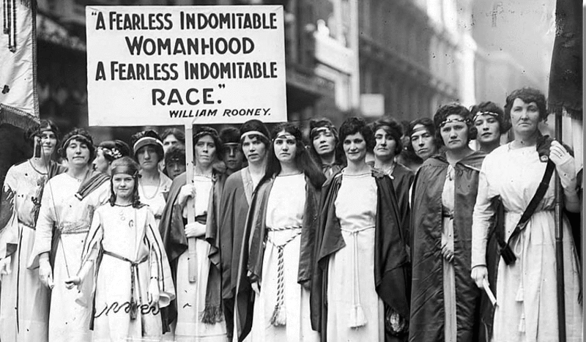
October 16, 2014
Image: Suffragettes in the St. Patrick's Day Parade on Fifth Avenue on March 27, 1921, by Paul Thompson

As a writing workshop instructor, I’ve become familiar with the garden-variety problems that graduate students face in writing a dissertation. Often those difficulties boil down to an avoidance of the daily grind of writing itself. Sometimes students lack any concrete feedback on their drafts or receive comments that are too general to be of much help in the revision process. Many students are unfamiliar with the tricks and tools of the writing trade itself – things like reverse outlines, free writing, or “storyboarding.”

My role is to help graduate students with the technical aspects of writing. But as I have counseled more and more of them, I have noticed a disturbing trend. While all of my students had trouble finding their voice or sticking to a writing schedule, some of my female students seemed to have an additional – and less technical – problem: a crippling lack of confidence. After a year of working intensely with Ph.D. and master’s candidates, I slowly realized that my female students were more likely than the men to feel as if something was fundamentally lacking about either their projects or their skills.

And apparently, that is a common problem. Last April, journalists Katty Kay and Claire Shipman wrote an essay in The Atlantic called “The Confidence Gap” about a disturbing trend they had noticed throughout the course of their careers. In interviewing countless female professionals, many of whom were widely considered to be at the top of their fields, Kay and Shipman said they repeatedly witnessed these extremely qualified women downplay the role that skill had played in their success. Kay and Shipman could relate, noting that they often felt “lucky” when they succeeded and personally at fault when they failed. In the article, they argued that “the power centers of this nation are zones of female self-doubt.”

In private one-on-one breakout sessions during my writing workshops, I often saw brilliant young women worried about their capacity not only to become scholars but even to finish their dissertations. One told me she didn’t know if her work was “good enough” to succeed. Another confessed that she felt unsupported and belittled by her male adviser and that negative remarks on her chapter drafts made her feel “dumb.” Some of the women wept openly as we talked. Others expressed anger or said they were on the verge of quitting the academy and abandoning their dissertations. (Keep in mind: Not all of my female students shared these problems, but a large enough number did to prompt this column.)

Maybe those conversations shouldn’t have surprised me, but they did. They also began to worry me. My female students seemed to have difficulty separating their work – and their writing – from themselves. And that lack of confidence was showing up in the writing itself.

First, I noticed that their prose was often littered with “maybe” or “perhaps,” “it seems” or “it appears.” In graduate school, I had once been advised to cut out all of those words from my essays because it made me look unsure of my arguments. A decade later, my own students were doing the same thing. I began to see other problems cropping up in their writing, all indicating various degrees of self-doubt and uncertainty.

This column is my own small attempt to bridge what I have come to see as “the confidence gap in academic writing.” Of course some of my male students also have confidence issues in their writing. But as a wonderful female scholar so aptly put it when I talked to her about this issue: “Women internalize criticism to the point of self-blame. Rather than seeing structural or other issues that can influence our work, we locate the issue within ourselves. We think ‘I can't do this’ or ‘I don't have the chops’ or ‘Something is wrong with me.’ That's not to say that men don't also feel these emotions or think these thoughts. But I feel like it's on a different register.”

And I agree with her. In preparing to write this, I spoke with several women working at different levels within the academy and none of them were willing to go “on the record” about this topic. I hesitated to even write this piece at all, partially because I didn’t want to contribute to the problem by blaming the victim. But in an effort to make anyone struggling with impostor syndrome feel less isolated, I decided to come out of the confidence gap closet to offer the following concrete tips on how to start writing with less self-doubt.

- Search for red flags in your writing. When you read your drafts, look for words that hedge your argument: maybe, possibly, perhaps, suggest, could, might, may, appears, seems, seemingly. Circle them to see if you’re overusing them. If you are using them to couch your argument, get rid of them. You don’t need to signal that you’re not sure about what you’re arguing. If your argument is unsound, you’ll get comments back from reviewers that say so.

- Don’t hide behind other authors or texts, no matter how amazing they are. There’s a fine line between using Judith Butler’s arguments to bolster your own and simply restating what she has said while adroitly avoiding making your own claim. I’ve seen a lot of essays with so many citations and paraphrases that the reader has a hard time figuring out where the author’s own voice begins and the famous theorist’s ends. (This is, sometimes, at the heart of the problem of finding one’s voice – see my earlier column for tips on locating yours.) Revise your chapters and articles so that your own argument takes center stage; everyone else is in a supporting role.

- When you receive comments on a draft, read them and then put them away for at least a day. I recommend a full week. In that time, remind yourself that criticism of your arguments, your structure, or your evidence is not criticism of you as a person. Your work is completely separate from your self-worth. The comment, “This needs work. Your argument is weak,” does not mean: “You need work. You are weak. You are too dumb to write this.” Learn to spot the difference between what is being conveyed in the comments on the page and your distorted interpretation of what isn’t being said. Don’t read between the lines. Only rely on concrete evidence. Until someone tells you, explicitly and directly, “You aren’t good/talented/smart enough to do this,” proceed in good faith that you are.

4. Finally, don’t quit for the wrong reasons. Don’t quit writing or avoid working on your dissertation or book or article because you think you’re not a good enough writer, or you can’t find your argument or structure, or you think everyone else is having an easier time of it. I promise you that you are, you will, and they aren’t. Really. Just write.

At some stage in our careers, we all struggle with uncertainty and self-doubt. The trick is to stop signaling doubt in your work itself and start signaling confidence (even if you don’t always feel very confident at first). The difference between “success” and “failure” in writing is often just tenacity and a few friends to remind us that we can do much more than we think we can. And, trust me, we can.
Theresa MacPhail is an assistant professor in the Science, Technology & Society Program at Stevens Institute of Technology.

See more at: https://chroniclevitae.com/news/760-the-confidence-gap-in-academic-writing?cid=chesectionpromo#sthash.WbAWbq1p.dpuf

