Inside Out
Supply the missing entries in each In-Out table. If you think there is more than one answer, describe the possibilities. Then write a rule for each table that tells what to do with the In to get the Out. Express each rule as a complete sentence, such as “The Out is 1 more than 4 times the In.” Be as clear as you can.

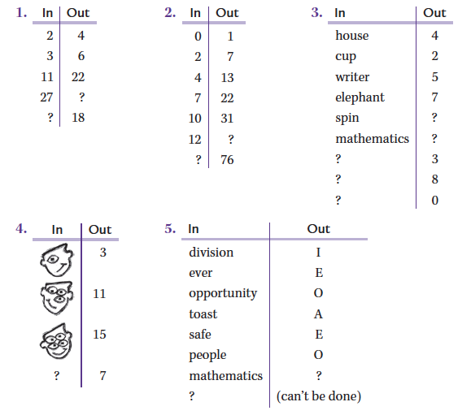

6. Create two In-Out tables of your own. Give both the table and the rule you used.

