Tuna Pasta Salad
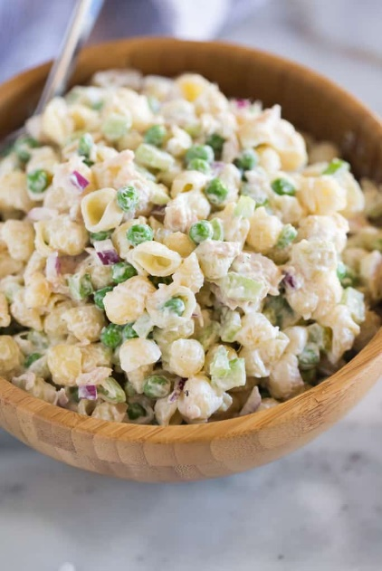
Prep time: 10 minutes
Cook Time: 10 minutes
Total Time: 20 minutes
Servings: 5

Ingredients:
- 8 ounces of your favorite pasta
- 7 ounces canned tuna, drained
- 2 ribs celery, chopped
- 1/4 cup red onion, chopped
- 1 cup peas, fresh or frozen
- 1/2 cup mayonnaise
- 1/2 cup plain Greek yogurt
- salt and freshly ground black pepper, to taste

Directions:
- Cook noodles according to package instructions, until al dente. Drain.
- In a large bowl add chopped onion and celery, peas, cooked pasta, and drained tuna.
- In a separate bowl, mix the mayo and Greek yogurt.
- Stir half of the sauce into the pasta mixture and toss to evenly coat. Season with salt and pepper to taste.
- Refrigerate pasta and remaining sauce separately, covered, for 30 min. Stir in remaining sauce and serve immediately.

Tuna pasta salad is a favorite when the weather starts to heat up. It's easy, fast and requires minimal ingredients. Great for lunches, snacks, dinners or can be served as a side dish. This recipe has several nutritional benefits as well. Did you know that tuna is an excellent source of healthy omega-3 fatty acids and is packed with protein? The two combined are crucial nutrients needed to decrease inflammation and support a healthy immune system. Greek yogurt also provides a protein source and adds a wonderful creaminess to the dish when mixed with mayo. Noodles provide a source of carbohydrates, which is your body’s most preferred source for energy. Vegetables in this pasta salad also provide vitamins, nutrients and fiber that will help you feel your best in and outside of the classroom. Easy, nutritious and delicious! Just store in the fridge and pull it out whenever you need a balanced meal or snack. Enjoy!

Recipes adapted from: https://tastesbetterfromscratch.com/tuna-pasta-salad/

