A Lot of Changing Sides
A housing developer submitted plans to the city planner for some houses she wanted to build. The lots in the plan were all squares of the same size. But the city planner thought that this plan was boring and insisted that the developer introduce some variety. After some discussion, the planner and the developer decided that the lots should include other types of rectangles. So the developer proceeded to change the lengths of some of the sides of the lots.
For each of the changes that were made to the square lots, complete these tasks.
- Make and label a sketch of the lot, using the variable X to represent the length of a side of the original square.
- Write an expression for the area of the new lot as a product of its length and width.
- Write an expression without parentheses for the area of the new lot as a sum of smaller areas. Use your sketch to explain this expression.
- The original square lot was extended 4 meters in one direction and 3 meters in the other.
- The original square lot was extended 5 meters in one direction only.
- The original square lot was extended 10 meters in one direction and 9 meters in the other.
- The original square lot was extended 1 meter in one direction and 25 meters in the other.
- The original square lot was extended 2 meters in one direction and decreased 2 meters in the other.

Why Are They Equivalent?
You have seen previously that the two expressions 2(X + 1) and 2X + 2 seem to give the same result no matter what number is substituted for X. In other words, the expressions appear to be equivalent. But it would be nice to be certain of this and to understand why the expressions are equivalent.
Randy, Sandy, and Dandy were having just that discussion. Read each of their explanations, and then do these four things.
- Decide whether any, all, or just some of them are correct, and explain your decision.
- State which explanation is the easiest for you to understand, and why.
- State which explanation is most convincing to you, and why.
- Adapt the explanation you understand best to explain in your own words why the expressions 3(X + 4) and 3X + 12 are equivalent.
Randy’s Explanation
“We all know that 2A is twice A, which is A + A. Think of 2(X + 1) as being twice X + 1. In other words, it is equal to (X + 1) + (X + 1). And (X + 1) + (X + 1) is equal to 2X + 2.”

Sandy’s Explanation
“It works with numbers! Check it out! If X is 5, then 2(X + 1) is 2(5 + 1), which is the same as 2 • 6, which is 12. And, well, 2X + 2 is 2 • 5 + 2, which is the same as 10 + 2, which is also 12! Wow!”

Dandy’s Explanation
“Multiplication is how you find the area of a rectangle, you know, length times width.
Basically, a product ab can be thought of as the area of a rectangle with dimensions a and b, like this:
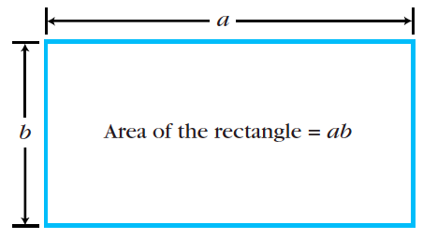
“The product 2(X + 1) can represent the area of a rectangle that is 2 units in one dimension and X + 1 units in the other. The length of X + 1 is like a segment of length X next to a segment of length 1. The picture is something like this:
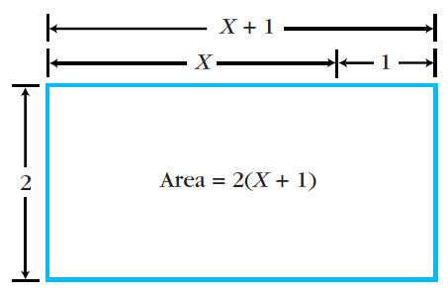
“A simple dividing line shows that this figure can be thought of as two rectangles, with areas 2X and 2, put together. Because we are talking about the same area, 2(X + 1) must equal 2X + 2.”
