Black Bean Tacos
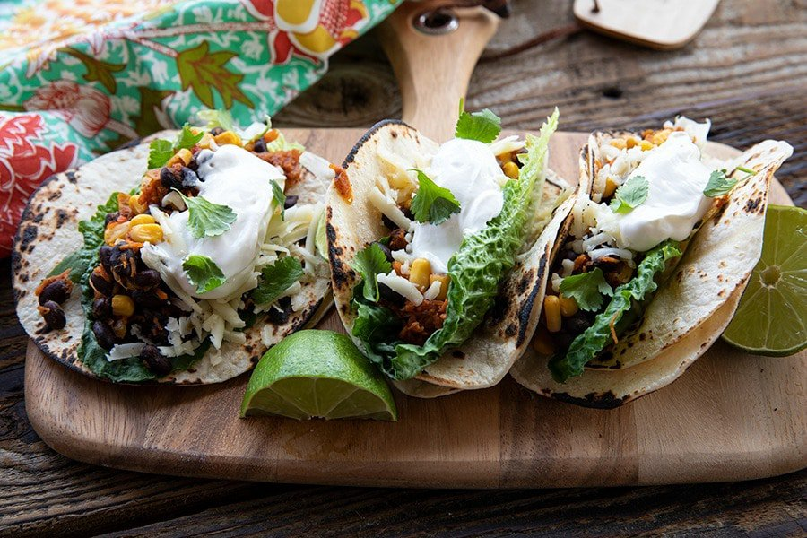
Prep time: 5 minutes
Cook time: 5 minutes
Servings: 4
Serving size: 2 tacos
Ingredients:
- 1 can of black beans, rinsed and drained
- 1 cup of corn, rinsed and drained
- 1-2 tablespoons of olive oil or canola oil
- 8 8-inch tortillas (flour or corn), warmed
- Cheese, to serve
- Sour cream, to serve
- Salsa and guacamole, to serve
Optional Ingredients (not typically offered at cougar pantry, but may help enhance flavor):
- 1-2 teaspoons of chili powder
- Lime, lettuce, and cilantro, to serve
Directions:
- Place oil in a saucepan and bring to a medium heat. Add black beans and corn, and reduce to a low heat. Cook for about 5 minutes while stirring.
- Divide bean and corn mixture evenly amongst the tortillas. Serve with your favorite taco toppings!

These black bean tacos are perfect for a quick lunch or dinner! Corn contains B vitamins, which helps maintain good energy levels, eye health, nerve function, hormone production, cardiovascular health, and muscle tone. Black beans are both a protein and carbohydrate, and they contain many vitamins and minerals that are important for our health. Black beans have been shown to help strengthen bones, protect the heart, improve digestion, lower blood pressure, and improve blood sugar levels. If you don’t have tortilla’s, you may substitute them with rice and make a burrito bowl instead!

Recipe adapted from: https://www.foodiewithfamily.com/black-bean-and-corn-tacos-10-minute-meal/

