The Worst Advice Grad Students Get
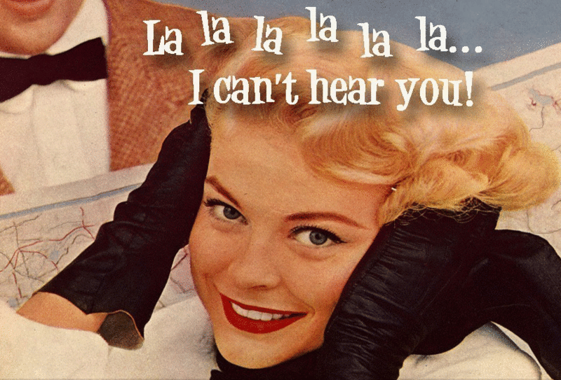
July 24, 2014

During my last year of grad school I participated in a professional-development workshop on crafting academic book proposals with A Real Editor. As long as we submitted our proposals in advance, she’d read them and offer a critique.
We were all very excited—and scared. If she liked our work, we could’ve had an “in” at one of the best presses around; if she didn’t, it could’ve meant a pass from the press for years to come.
When I finally got to the day of the workshop, I was so nervous I could hardly talk (and, if you know me, you know that never happens). But, to my surprise, she liked my proposal. She really liked it. She wanted me to keep her posted on my dissertation progress, and to send her my dissertation when it was done.
I excitedly told this to a faculty mentor. No, no, no, Faculty Mentor said. Your dissertation is not done, and a dissertation is not a book. “Keeping in touch” would end up making me look foolish, because I would end up wasting everyone’s time—the editor’s as well as the potential readers’. Better to do nothing so as not to embarrass myself (and, potentially, my mentor).
So I did nothing. And you know what? I’ve never been able to interest the editor in my work again.
Though that situation sticks in my mind, it’s not the worst advice that I’ve personally received—that would be the never-have-a-baby advice that I wrote about in my last column—and it pales in comparison to horror stories I’ve heard from friends and colleagues over the years. But it does show how advice you get in grad school, and early in your career, shapes your future opportunities, for good or ill.
I’ve heard a lot of bad advice over the past decade and change. Not all of it was to me personally—instead this is a collection culled from years of being a student, working as an adjunct, and networking in my field and beyond (Thanks, Twitter!). Unlike a lot of my columns, this is aimed at people in or entering grad school. We all have those people in our lives, so if it doesn’t apply to you, feel free to share:
1. “Go to the best grad school that accepts you, even if that means no funding.” In the words of Nancy Reagan, “Just say no!” Yes, there are people who make this work—two of the most successful students in my grad program were admitted without funding and ended up securing it for subsequent years. But the vast majority of people who enter without funding end up with massive loads of debt, sometimes without a degree in hand.
A good friend of mine entered a prestigious program with advanced standing—but without funding—after earning her M.A. at a state school. After paying her way for a year, she did eventually secure funding; however, she left the program without a degree. The tuition for one year alone was nearly $40,000, which she now has to pay back with interest.
A better piece of advice (beyond the standard “Just Don’t Go”): Go to the best grad school that will give you a free ride and fit your interests. The “best” grad school for you may not be the fanciest name in the bunch; find people whose research complements yours and who are decent human beings. If you don’t get funded at the grad school of your choice, and you feel like it’s the thing you feel must do with your life, still don’t go. Instead, reapply in a year with stronger materials.
2. “You belong in a Ph.D. program, so don’t bother finishing this master’s you’ve already started.” I was lucky: I entered a Ph.D. program that gave out multiple degrees along the way. I got an M.A., but I also got an M.Phil. after I passed my comps on my way to the Ph.D., which means I only had to buy an extra frame along the way for my extra piece of paper.
Many other people are not so fortunate. If someone encourages you to apply to a Ph.D. program while you’re still in an M.A.-only program, you should be flattered. And then you should go back to your apartment and think very, very carefully. Are you interested in going for the Ph.D. program because it feels great to be told you’re smart? Or are you interested in a Ph.D. program because your master’s program has introduced you to a world of research and teaching, which you want to do for the rest of your life?
Even if you do want to go on to the Ph.D., finish that master’s first. You might think that M.A. doesn’t matter if you have to repeat a lot of work in the Ph.D. program. It does matter. But all kinds of things can go wrong on the way to a Ph.D. Finish the shorter program first.
3. “Attend as many conferences as you possibly can—it’ll pay off.” Obviously, going to conferences is a great idea—you want to present your research, network with potential mentors and colleagues, and make friends with people who do similar work (or are just nice folks). The problem is when “as you possibly can” translates into something detrimental to your finances.
Most senior professors—even, or perhaps especially, those who call themselves Marxists—do not understand what percentage of a grad student’s or contingent faculty member’s wages will be eaten up by a conference. Their days of paying for everything on credit cards are long in the past; plus, they probably get at least some research funding (though I’m sure it’s less than in the past).
Be strategic about attending conferences. Attending the big conferences in your field is great, but a lot of times, smaller ones are more productive and cheaper. I had my first real conversation with one member of my dissertation committee at a small conference in upstate New York after trying unsuccessfully for two years to track her down at bigger events. My only cost for that conference was a bus ticket, since the university paid for food and I stayed with a friend.
4. “Don’t publish until you are ready (some nebulous time in the future).”Sometimes advice can be good or bad, depending upon when you receive it. Most of the time, first- and second-year grad students probably don’t have the sense to know if what they want to publish is original or literally the same thing that every first-year grad student has written in her second-semester seminar paper for the past 20 years.
And then something sets in, otherwise known as the Dunning-Kruger effect. The scale tips from thinking you know everything to telling yourself repeatedly that you know nothing, Jon Snow, and curling into a fetal position when someone mentions peer review. At that point, you may never feel ready to publish. You’ve experienced that one particularly mean faculty member’s vicious comments a few too many times.
But fear of peer review will get you nowhere. Learn to tell the difference between the “OMG, I AM BRILLIANT! BOW DOWN, BITCHES” narcissism of your academic youth and the quiet, “Yes, this is worth publishing” inner voice that you can only develop by trying to publish things and maybe failing a few times.
5. “It doesn’t matter who your advisor is.” Oh, yes, it does—in more ways than you can count. For example, an untenured faculty member can be a fantastic fit for your project, but if she doesn’t get tenure, your standing in the department will be weird, to say the least. I know—this happened to me. I ended up taking a lot longer to write my dissertation than I probably should have, and at least part of it was because communicating over email and phone is no substitute for an in-person meeting.
The choice of advisor matters in other ways, too. People who are great matches on paper may be total jerks in person. Or they may not be interested in your work, for whatever reason. Or they could be too nice—if they don’t give useful feedback to your earlier papers, how do you think they’re going to act when it comes to the dissertation? You don’t want to get to a defense where your super-nice advisor then defers to the one highly critical member of your dissertation committee.
A friend of mine always tells his students, “If you apply to grad school, make sure there are at least two tenured people in the department you think you can work with.” My friend is smart.
In the end, you cannot account for all the twists and turns that may happen during grad school (or after). Taking the good advice to heart and jettisoning the bad will not guarantee you a tenure-track job upon graduation. But you can, at least, know that you made the best decisions you could, with the best information possible.
Elizabeth Keenan is an adjunct instructor at Fordham University.

https://chroniclevitae.com/news/623-the-worst-advice-grad-students-get

