The Secret to Hitting Your Writing Goals May Be Simple: Peer Pressure
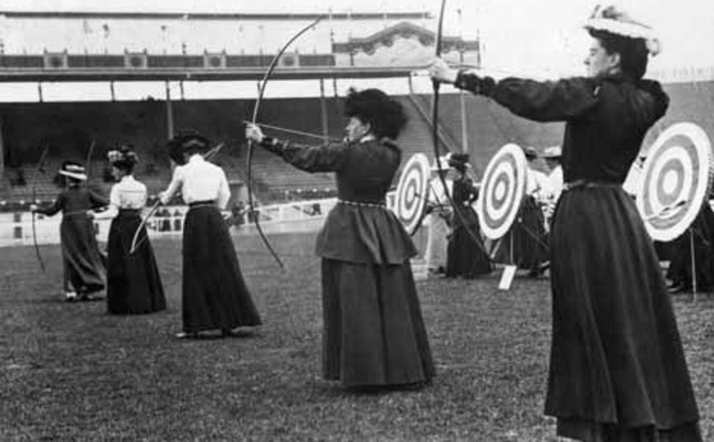
June 17, 2015
Image: Britain's Sybil 'Queenie' Newall winning the ladies archery at the 1908 Olympics (via Creative Commons)
From The Chronicle of Higher Education
It’s summertime, when scholars dream of doing all the writing they didn’t find time for during the academic year. But some have found a year-round, low-budget solution to the academic writer’s time crunch: Schedule a meeting.
Although meetings often deserve their reputation as gatherings where productivity goes to die, there’s one that Virginia Matzek, an assistant professor of environmental studies and sciences at Santa Clara University, looks forward to: the get-together of her faculty writing group.
Its name — "Shut Up and Write" — sums up its approach. No idle chatter, no workshopping manuscripts, no wasting time, just a bunch of people from different departments and disciplines who all need to log some writing hours. "You’re going to put your head down and get work done," says Ms. Matzek, who will go up for tenure next year.
Shut Up and Write is by no means the first such faculty group, but it’s part of a growing effort among academics, especially those early in their careers, to make sure they have time for an essential but easily disrupted part of their jobs. Getting tenure is tough these days, tougher still if you don’t have a good portfolio of publications, but teaching and service obligations can eat away at writing time. "You’re not going to push back your office hours or not show up for your class," says Ms. Matzek. "But writing doesn’t have that kind of privilege in your calendar. It can always get pushed back" — unless you treat writing time with the same seriousness as you would any other professional obligation.
"If you say you have a meeting, it’s the end of discussion," Ms. Matzek says. "Nobody challenges you when you say you have to go to a meeting. You don’t have to be specific about what the meeting is."
Although they often spring from grass-roots efforts, faculty writing groups sometimes get a boost from campus administrations, with sympathetic deans or faculty-development groups organizing summer writing retreats and boot camps or meetups during the year, occasionally with a free meal thrown in. Many institutions belong to the National Center for Faculty Development and Diversity, headed by Kerry Ann Rockquemore; the center runs a popular Faculty Success Program that aims to help academics develop good writing and productivity habits, among other survival skills.
Naomi Levy, an assistant professor of political science who co-organized the Shut Up and Write group about three years ago at Santa Clara with Ms. Matzek, is training to be a coach in Ms. Rockquemore’s program. "A lot of it is about finding the balance that aligns with your institution’s expectations and sticking to it," she says.

The Power of Shame
Whether formal or informal, writing-accountability groups operate with a couple of basic assumptions: You’re more likely to get writing done if 1) you book regular time for it and 2) you find colleagues to help hold you accountable. The power of scheduling and the equally formidable power of shame underpin writing guides like Paul J. Silvia’s How to Write a Lot: A Practical Guide to Productive Academic Writing (American Psychological Association, 2007), which has become something of a cult classic for academic writers. A writing group "builds social pressure. It also builds the habit," says Mr. Silvia, an associate professor of psychology at the University of North Carolina at Greensboro.
Although some academics prefer what Mr. Silvia calls the lone-wolf approach to writing, others — particularly in the book-heavy humanities — benefit from a collective boost. "There’s really no desperation quite like assistant-professor-working-on-a-book desperation," Mr. Silvia says.
For years he’s belonged to a writing-accountability group at UNC called Agraphia, a nod to a medical condition that renders people unable to write. The group assembles at a coffee shop near campus for just 10 to 15 minutes every week. Mr. Silvia keeps a file folder with a paper on which everybody’s weekly goals are written down, to be revisited the following week. (The writing itself happens on their own time.) "We keep it crisp," he says.
At Santa Clara, Ms. Matzek and Ms. Levy keep the mechanics of their group simple. At the beginning of each quarter they send out a general announcement. Usually 20 or 25 people express interest, and a smaller core group turns up regularly. Most of the regulars don’t have tenure yet, according to Ms. Matzek.
Sessions don’t usually run longer than an hour and a half or so. People show up, write a goal on a whiteboard — finish this chapter, do those footnotes — then get up and cross it off once it’s done. Beyond writing, "there are people who are editing video, there are people who are analyzing data," Ms. Matzek says. "That task that you need to make yourself do, you can come do."
Julia Voss, an assistant professor in the English department at Santa Clara, has found the approach so useful that she started a departmental group with a couple of senior colleagues. It was hard to find mutually convenient times to meet, though, so this year they’ve been doing it virtually. "It’s really motivating for me to open up my email in the morning" and see how everybody’s doing with their goals, says Ms. Voss.
At Santa Clara and other smaller, liberal-arts institutions, meeting up to write also offers junior faculty in particular a research-friendly break from the institutional focus on teaching. At Colgate University, a writing-accountability group organized by Meg Worley and a colleague steers clear of the classroom. Ms. Worley, a medievalist who’s an assistant professor of writing and rhetoric, makes a sideways reference to the famous quote from Fight Club: The only rule of writing group is "you don’t talk about teaching."
The all-female group comprises early-career academics faculty from all of the college’s divisions; postdocs and visiting faculty are welcome too. In addition to setting weekly goals, the group functions as a support network. "We also talk about self-care," Ms. Worley says, adding that she doesn’t like the term because "it’s a little too squishy for me." Whatever it’s called, that support comes in especially handy for junior female faculty, she says, because often they "get pushed to open a vein for the institution."
To help one writer get out of her rut, the members of the group took turns as her writing buddy. "All week long, everybody did one hour writing with her," Ms. Worley recalls. "And by the end of the week, she had gotten out of the quicksand."
Maybe it’s time to add "Organize a writing group" to your fall calendar.
Jennifer Howard writes about research in the humanities, publishing, and other topics.
- See more at: https://chroniclevitae.com/news/1037-the-secret-to-hitting-your-writing-goals-may-be-simple-peer-pressure?cid=VTEVPMSED1#sthash.yhR5jz46.dpuf

