In Need of Numbers
Graph sketches describe a situation, but the description is more complete when the graph includes numeric information.
You can provide this information by putting a scale on each axis. The scale shows the numeric values that the points on each axis represent.
To scale an axis, decide what range of values is appropriate for the situation and for the quantities involved. You also have to decide how to display the scale on each axis.
For each sketch, (A) scale the axes with appropriate values, then (B) Write down why your scales are reasonable and the assumptions you made.

1. | 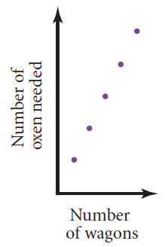 | 2. | 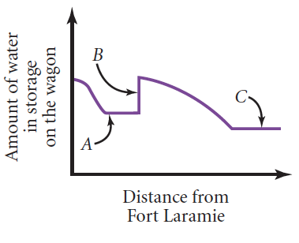
3. | 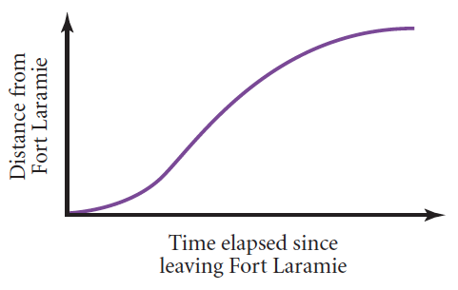 | 4. | 