Accessibility FAQ

Do I need to make my content accessible even if I do not have a DSS Student in my class?
Yes, ALL content needs to be made accessible. Not all students self-identify as having a disability/needing DSS assistance and ALL viewers will benefit from having multiple ways of navigating your information.

How long do I have to make changes to my content?
Fall of 2013 was the baseline measure, ideally in Spring/Fall 2014 all documents will be compliant.

Is there a place with information/a person to contact if I have questions or need help?
Yes! If you have questions you can email them to: accessibility@csusm.edu or fill out a form on the http://www.csusm.edu/accessibility/staff/staffform.html
On the Accessibility website’s “Guides & Resources” tab, there also are easy to follow guides which will act as a good refresher on topics covered today.

Workshop dates:
- Wednesday, April 16, 2014 from 1:00 pm to 2:30 pm at ACD 209
- Monday, April 21, 2014 from 1:00 pm to 2:30 pm in ACD 209
- Thursday, April 24, 2014 from 1:00 pm to 2:30 pm at ACD 209
- Tuesday, April 29, 2014 from 9:00 am to 10:30 am at ACD 209
- Thursday, May 1, 2014 from 9:00 am to 10:30 am at ACD 209

Creating Accessible Documents in Microsoft Word
The first step to creating accessible documents is tagging headings. Headings should be tagged in a logical reading order and should not exceed three levels.
Example of how this would look:
Title – Heading 1
Chapter – heading 2
Section – heading 3
Section – heading 3
Chapter – heading 2
Section – heading 3

Lesson 1: Creating and Modifying Headings
Heading 1
Content content content
Heading 2
Content content content
Heading 3
Content content content
Can’t find a heading? Selecting the icon in the “Styles” section will bring up all of the preset heading styles or create your own.

Lesson 2: Creating a Linked Table of Contents
Put table of contents below:

Lesson 3: Alternative text
The following is an image/graph of the ten most popular undergraduate majors on CSUSM’s campus. Give the image an Alt. Text tag that explains the idea being represented.
Example 1: Image of graphs
CSUSM’s Top 10 Most Popular Majors
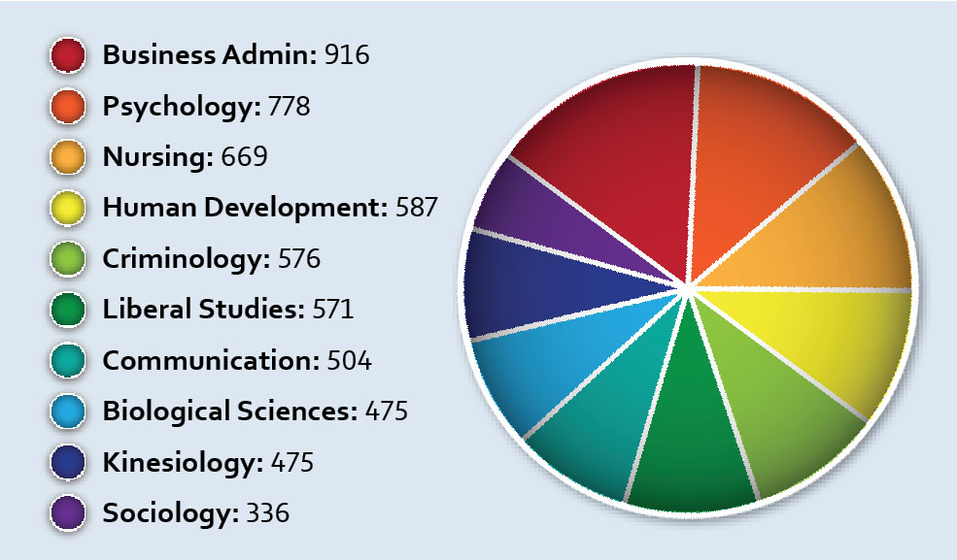
Example 2: Decorative images
Join us for a Bridal Shower for
Ms. Jane Doe

August the 7th, at 3pm
Hosted by Mother Hubbard
123 Strawberry Lane
Example 3: Logo use
CSUSM Dean’s List 2055
Congratulations for your achievement of being on the Dean’s List for the Spring 2055 term! Please accept this awesome certificate and print it out to show off to all of your friends and family.

Example 4: Image use within CC
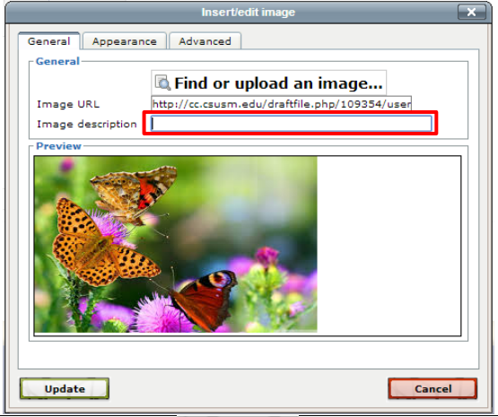

Lesson 4: Labeling Tables
Data tables: explains data in a visually organized way.

Sports preference | Males | Females
Football | 82 | 13
Soccer | 34 | 59
Baseball | 14 | 6
Tennis | 3 | 15
Cross Country | 25 | 48
- Mark the header rows
- Insert caption above table

Layout tables: require an explanation of the idea behind the table, such as “Male Facial Expressions”

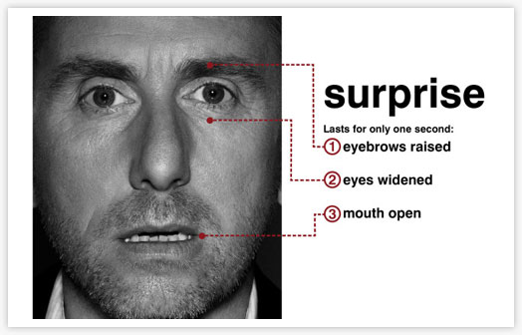 | 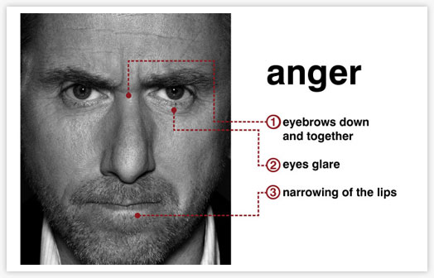
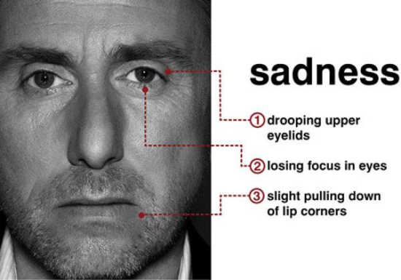 | 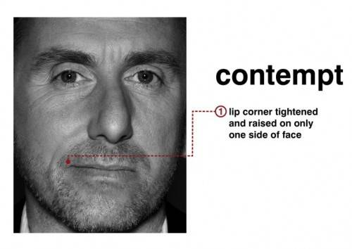

Lesson 5: Design and Links
- Pay attention to white spaces on the page. Do not use Enter Keystrokes, instead use page breaks

- Use a high level of color contrast for all materials!

Links: Which one is easier to understand at a glance?
To learn more, visit the Accessibility page | To learn more click here.

Add in your own descriptive hyperlink below:

Lesson 6: Saving as a PDF
All of the edits made to this document will be saved to the PDF.
Congratulations, you now have accessible Word and PDF documents!

