Green Bean Chicken & Rice Casserole
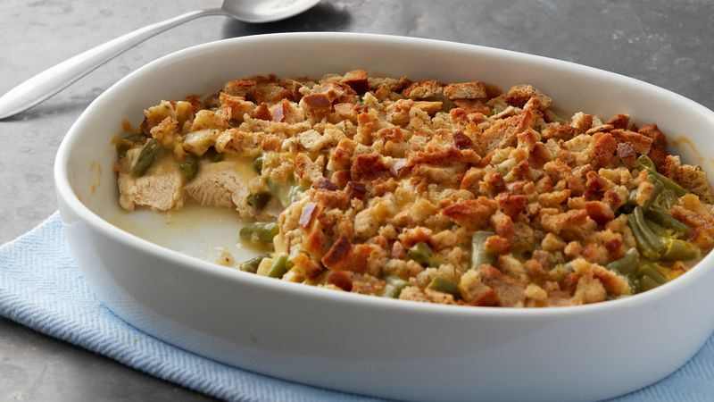
Prep time: 10 minutes
Cook time: 50 minutes
Servings: 4

Ingredients:
- 2 teaspoons olive oil, divided
- 1 onion, diced
- 1 cup brown rice
- 1 ¾ cup water
- 2-3 cans of chicken, drained
- 1 can Campbell’s Cream of Mushroom Soup or Cream of Chicken soup
- 1 canned green beans, drained
- ½ teaspoon paprika
- ¼ teaspoon black pepper
- Crunchy french onions, optional

Directions:
- Preheat the oven to 350 degrees F.
- In a saucepan, turn on heat to medium-high and add olive oil. Once oil is warm, add onion and saute until translucent, about 3-5 minutes. Add rice and water. Stir.
- Bring wild rice and water to a boil over high heat. Once boiling, reduce heat to medium-low, cover, and simmer until the rice is tender but not mushy (20-25 minutes).
- Once done, turn off the stove and cook with the cover on for an extra 5 minutes. Drain off any excess liquid, fluff rice with a fork.
- While the rice is cooking, heat 1 teaspoon oil in a pan over medium heat. Add the canned chicken and cook until warmed and slightly brown, about 3-5 minutes. Combine the rice, chicken, mushroom soup, green beans and spices in a large baking dish. Stir to combine and mix. If using crunchy french onions, spread a thin layer on top of the casserole.
- Bake in the preheated oven for about 30 minutes. If prefered, add shredded cheese on top the last 5-10 minutes of cooking, or top with cheese once out of the oven.

This casserole is the perfect warm and savory dinner that is packed with protein, fiber and whole grains. Everything you need to rebuild and recover sore muscle tissues and provide an excellent source of carbohydrates to fuel you for your next day. Ideal for after a big game and amazing for lunch once reheated. Adapted from:https://www.allrecipes.com/recipe/62459/chicken-rice-and-green-bean-casserole/

