The Campus Style Police: "Your Look is a Bit Wild."

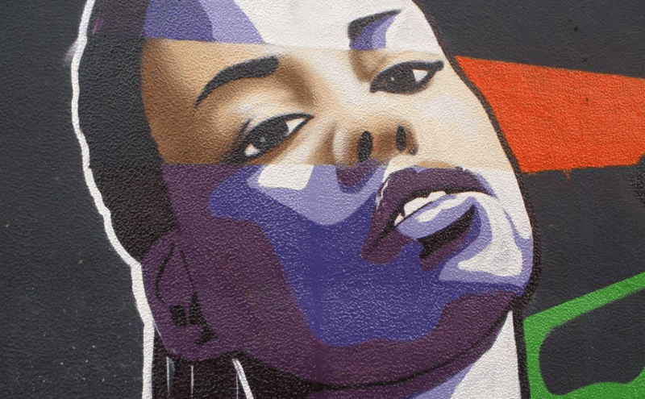
December 5, 2014
Image: Graffiti en Teruel, by Zarateman
In my early years of teaching, I considered myself fortunate that I escaped any negative assessment from my peers of how I looked or what I wore. As an adjunct professor teaching a class here and there in addition to my off-campus work, I flew under the radar. I was 20-something and had yet to really define my personal style. And I either didn't pay much attention to what my colleagues were saying, doing, or perceiving, or I simply hadn't made myself a target yet.

But a few years ago, six words changed that. Six words would quickly catapult me from unknown and unseen to the ranks of those professors of color who find themselves defending their physical appearance.

"Your look is a bit wild."

Those six words were spoken by a well-intentioned colleague who sat in on a workshop I was teaching for the college's professional development series—a workshop, ironically titled, “Cultural Competency in the Workplace and Classroom.” I suppose she didn't have any idea who I was or where I'd come from. Remember, I’d been in and out of academe up until that point. The workshop was a way for me to intentionally be noticed, should I ever desire to apply for a full-time position.
I suppose she was impressed with my presentation and wanted to help me make the connections I needed. I also suppose that, in her mind, my dreadlocks, though neatly coiffed, my extra piercing in one ear, and my preference for prints and bright colors (though usually muted by a more neutral/conservative complement) were all "too much" for an academic environment.

Since then, I've had colleagues tell me outright that it's not a good idea to dress too fashionably or on trend because students would not respect me and department heads would likely not take me seriously. Not to mention the many other microaggressions, such as the administrator who requested I send her a photo of myself and said, "Make sure it's professional.” That was something clearly not said to other professors (I know because I asked), but said to me because … well, I don’t know why. Professionalism had never been an issue for me.

I wish those were isolated experiences. I wish they were just a few kooky uber-traditional academics’ opinions. But sadly, such remarks are a common experience—a rite of passage, in some circles—for many academics of color.

The policing of physical appearance and dress is not a new phenomenon for women in academia. In a recent blog post for The Guardian, Francesca Stavrakopoulou notes: “I dress smartly but not formally for work. I wear what I’m comfortable in—both physically and socially. But for some, my heels are too high. My hair is too long. My smart jeans are too modern. Apparently, for some people I look too ‘glamorous,’ or too ‘feminine,’ to be an academic.”

I posit that, for women of color, this particular experience is more acute and has even more dire outcomes. On the one hand, the Richard Wright-esque duality that we must master becomes a kind of binding force that hinders authenticity. “I think these days, we all tend to fall into three categories: the free woman of color who works hard to not let societal norms dictate who and what she is, the encumbered woman of color who doesn’t attempt to be free for fear of backlash, and the middle-ground woman of color, like me, who is constantly in flux regarding being true to herself while regulating societal norms,” said Shonell Bacon, an instructor of mass communication at McNeese State University. “We might be seen as ‘too ethnic’ if we’re too free, and we might be seen as too plain, too much like everyone else if we’re encumbered, and either side of the spectrum could keep us from advancing in our career or being a representative of our school.”

On the other hand, assumptions made about a person of color based on superficial and prejudiced views of “appropriate” hair, dress, and clothing—particularly if held by those with administrative and hiring power—can affect critical decisions, including promotions and committee appointments.

Shanika Carter, a former adjunct professor at a college in Michigan said, “There was a period where I was constantly interviewing and not getting hired, although I know I aced the interviews. I felt like I was more confident than the ones interviewing me! It was as if they seemed a little intimidated. I initially thought it was because of my education credentials but then I began to wonder if it was due to my hair as I began to hear more and more stories about the experiences of other ‘natural’ women in the workplace.”

Angela Jackson-Brown, an assistant professor of English at Ball State University, said she had not experienced any direct comments regarding her dress, hair, or appearance while teaching at the university level. However, she did receive advice about her hair when she was on the academic job market: “When I was a student years back, a ‘well-meaning’ professor suggested I not wear braids on job interviews because my look might make me come across as ‘too ethnic.’ My reply was, ‘I wouldn't want to teach anywhere that my hair would cause people to lose sight of my intellect and scholarship.’”

Bingo!

Admittedly, some of what we perceive as negative comments from colleagues and administrators could be our own projections. It can be easy to project the generalizations and racial profiling we often experience outside of campus onto our colleagues in academia who may or may not be engaging us in the same ways.

Bacon also shared her own inner struggle with this: “I’ve never been called out on it, but I do often find myself self-regulating my hair. It’s natural. It’s long. It has the tendency to get rather large if I let it be how it wants to be. I find myself finding ways to ‘tame’ it, to keep it down, keep it flatter, less noticeable, and I think these feelings stem more so from society’s often negative thoughts regarding women of color’s natural hair.”

Certainly I'm not advocating that showing up to teach in—gasp!—a bikini is appropriate. Or even just appearing unkempt, for that matter.

Students will surely size a professor up and sometimes our attire can create some dissonance for them, as Carol Hood, an English professor in Chicago, found out. “I had a run in with an older student,” she said, “who insinuated my dress made her a bit skeptical of my credentials, to which I calmly reminded her that I am an award-winning writer with not one but two masters degrees.”

But students don’t hold the power to promote a professor or extend greater opportunities and responsibilities within the department. Their point of view matters, of course, but only so much, politically. Sadly there are some people who do have that power and who clearly believe that the natural texture of my hair—the way it grows out of my head—is inherently unkempt no matter how much time I spend at the salon.

So I will concede that we all operate with a filter that is filled with our situational and environmental experiences, and yes, even our preferences and biases. But when that filter is so influential in our perceptions and decision making that it can affect the progress of someone else’s career, it’s problematic.

And that’s what happens. How often it happens can certainly be debated. But once, I believe, is one time too many.

Professors, in general, spend years teaching students to think critically and to see beyond generalities; to support their positions and arguments with evidence that is logically, ethically, and/or emotionally sound. Consequently, these same professors should make sure they are not running wild with their own assumptions when it comes to colleagues who may dress or look differently.

Tracey M. Lewis-Giggetts is a writer, editor, and adjunct professor of English, writing, and publishing at several colleges and universities in the metro Philadelphia area.

https://chroniclevitae.com/news/826-the-campus-style-police-your-look-is-a-bit-wild#sthash.cZfnhytQ.dpuf

