Family Constraints
- The Hickson household contains three people of different generations. The total of the ages of the three family members is 90.
  - Find reasonable ages for the three Hicksons.
  - Find another reasonable set of ages for them.
  - One student, in solving this problem, wrote
C + (C + 20) + (C + 40) = 90
- What do you think C rep this equation?
- What do you think the student had in mind in using the numbers 20 and 40?
- What set of ages do you think the student came up with?

- There are four members in the Jackson family, again representing three generations. As in the Hickson household, the total of the ages of these people is 90.
  - Find a reasonable set of ages in which there are two children, one parent, and one grandparent.
  - Find a reasonable set of ages in which there is one child, two parents, and one grandparent.
  - Find a reasonable set of ages in which there is one child, one parent, and two grandparents.
  - In working on Question 2a, one student wrote
C + C + (C + 18) + (C + 36) = 90
    - What does C represent here?
    - What assumption seems to be implied by the fact that the equation begins with C + C ?
    - What do you think the student had in mind in using the numbers 18 and 36?
    - Why do you think this student used 18 and 36 while the student in Question 1c used 20 and 40?
    - What set of ages do you think this student came up with?

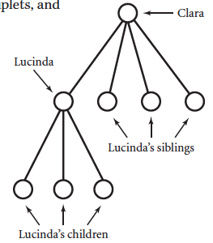
- Clara Dalton is the mother of Lucinda, one of a set of quadruplets. Lucinda is the mother of triplets.
The family tree here shows Clara, her quadruplets, and Lucinda’s triplets.
The sum of the ages of these eight people is 201.
Find a reasonable set of ages for these people.

