Tuna Melt Sandwich

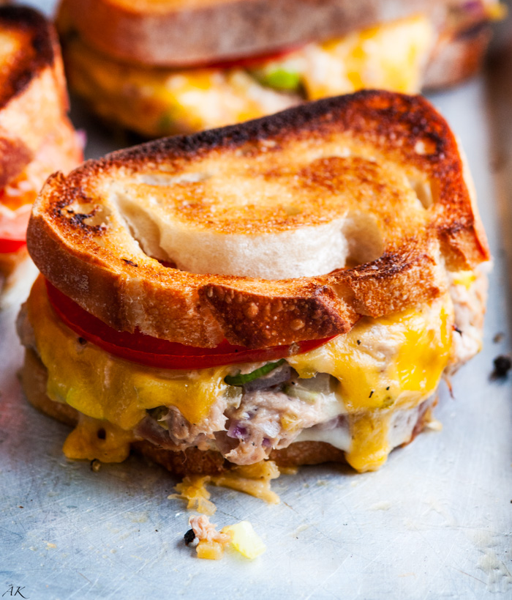
Prep time: 15 minutes
Servings: 1
Serving size: 1 sandwich

Ingredients:
For the Tuna Salad
- 2 ½ 3-ounce packages/cans of tuna
- ¼ cup mayo
- ¼ teaspoon salt
- ¼ teaspoon black pepper
- 2 teaspoons dijon or other mustard, optional
- 2 tablespoons lemon juice (~1 lemon), optional
- 2 Tbsp pickle relish, optional
- ¼ cup diced celery (~2 ribs), optional
- ¼ cup red onion, chopped, optional

For the Sandwich:
- 2 slices bread
- 1 tablespoon butter (½ tablespoon each slice)
- 1-2 slices of cheddar, provolone, swiss or other preferred cheese
- 1-2 thin slices tomato
- 1-2 lettuce leaves, optional
- Jalapenos, optional

Directions:
- In a large bowl, combine all ingredients for tuna salad and mix thoroughly.
- Spread butter on one side for each slice of toast. The side with butter will be the outer layer of the sandwich.
- Heat pan and place bread with the buttered side down on pan.
- Place a slice of desired cheese with a hefty spoonful of tuna salad in the middle of bread. Top with another slice of cheese (if desired) and thinly sliced tomato. Then place the other side of bread on top.
- Fry for about 3-4 minutes, or until outside gets lightly brown and cheese is melted.
- Carefully flip and repeat. Serve when finished.

These tuna melts are the ideal sandwich for after a workout, lunch or dinner. Perfect for when you are in the mood for something warm and savory. Tuna has anti-inflammatory effects from the healthy omega-3s that will help in recovery and tissue repair. It’s high protein source gives you long-term energy and keeps you fuller for longer. The bread on the other hand, provides quick energy from carbohydrates that give you immediate fuel and help with blood sugar regulation. Tomatoes also add color, freshness and are packed with antioxidants that help keep our bodies healthy and happy.

Recipes adapted from: https://www.aberdeenskitchen.com/2016/11/sheet-pan-sourdough-tuna-melts/

