The Issues Involved
- In In Need of Numbers, you put appropriate scales on the axes of different graphs.
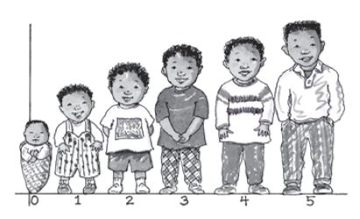
Make a list of difficulties you had and questions you would like answered that are related to scaling the axes of a graph.

- Here are some questions about scaling. Use examples to explain your thinking. Be detailed in your explanations.
    - Should the vertical axis always begin at zero? What is the effect if the axis does not begin at zero? What about the horizontal axis?
    - Once you have decided on a scale, how do you decide which numbers to write along the axes?

- The graph shows the average height of boys in the United States at different ages.
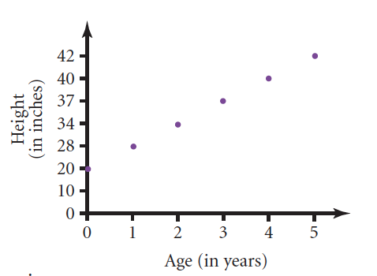
The graph seems to suggest that boys grow at a constant rate through age 5.
    - Why might someone make this conclusion from a quick glance at the graph?
    - Why is this conclusion incorrect?
    - Redraw the graph so it is not misleading.

- Suppose you wanted to sketch a graph showing the number of horse births on one ranch over the past 20 years. Would you use a continuous or a discrete graph to represent this situation? Why?

