Overnight Oats
Prep time: 5 minutes
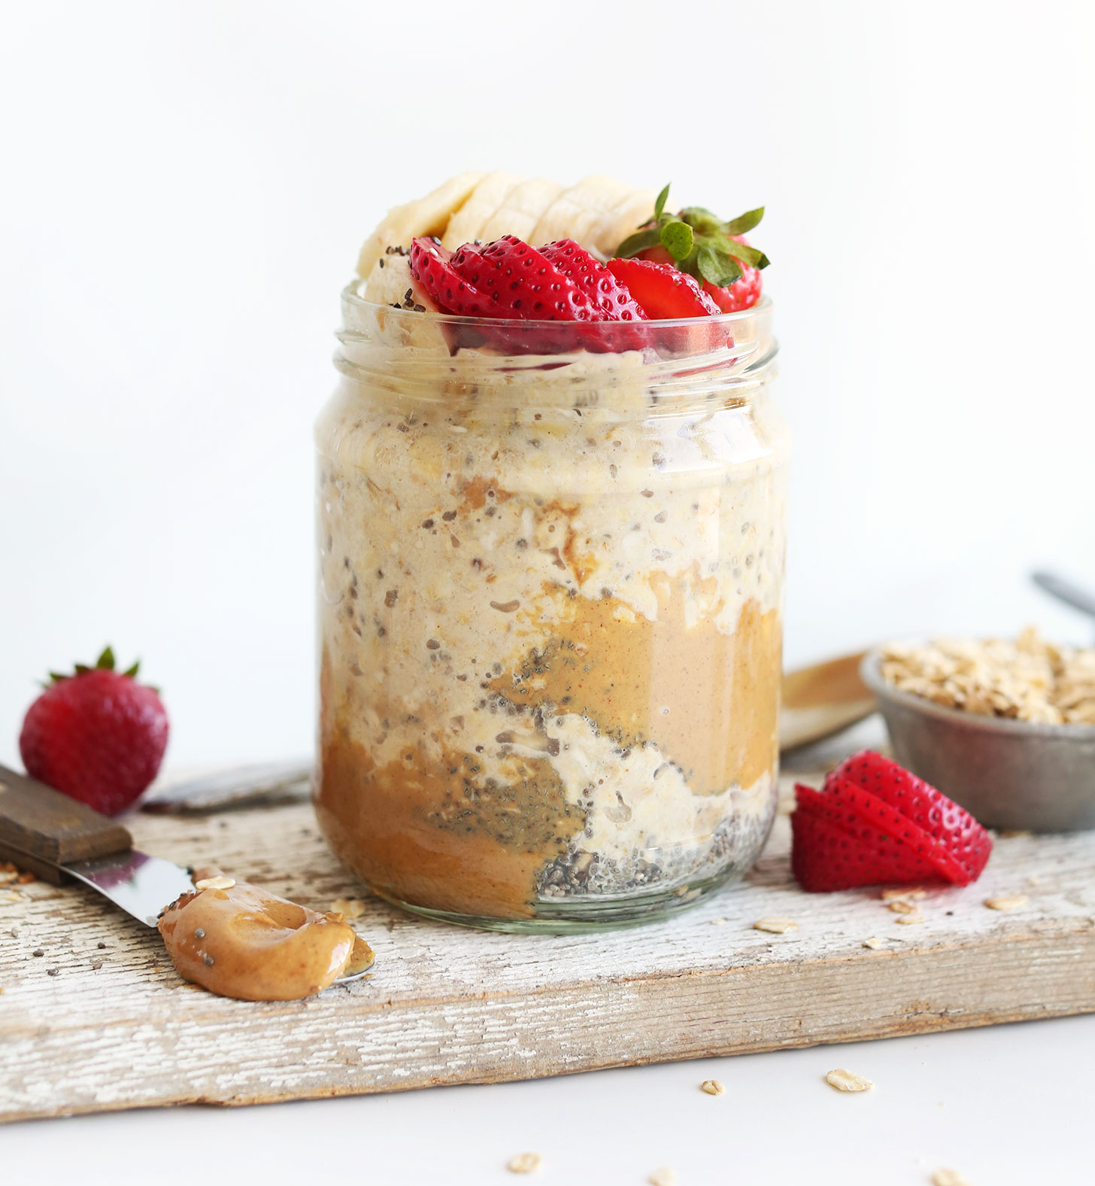
Total time: 4 hours +
Servings: 1
Serving size: 1 jar

Ingredients:
- ½ cup unsweetened milk of choice
- ½ cup rolled oats
- ⅓ cup yogurt of choice
- 1-2 tablespoons honey or maple syrup
- Pinch of salt

Optional Ingredients:
- ¾ tablespoon chia or flax seeds
- ½ mashed banana
- 2 tablespoons peanut butter or nut butter
- 2 tablespoons unsweetened cocoa powder
- Canned, fresh or frozen fruit of choice
- Coconut flakes
- Nuts or seeds for topping
- Granola for topping
- Spices: cinnamon, nutmeg, clove
- ½ teaspoon vanilla extract

Directions:
- Place all ingredients in a mason jar and shake. If you do not have a mason jar, you can also combine all ingredients in a bowl in whisk. Spoon into a jar with a tight-fitting lid.
- Close jar and refrigerate overnight or at least 4 hours before eating.
- In the morning, add more liquid if you'd like. Once you have achieved the desired consistency, top with desired ingredients.
- If you like warm oats, place in the microwave for about 1-2 minutes.

Overnight oats is the perfect grab-and-go breakfast that will have you thanking yourself in those rushed, early mornings. It's an easy no cook and nutrient-dense breakfast or snack. Great for taking to class or when leaving for away games. Oats have a special type of soluble fiber, known as beta-glucan, that helps slow digestion, increase satiety, binds bad cholesterol out of the body, and helps regulate appetite. They are also rich in fiber, protein and B vitamins that help energize you for the rest of your day.

Recipe adapted from: https://minimalistbaker.com/peanut-butter-overnight-oats/

