Teaching Statement as Self-Portrait

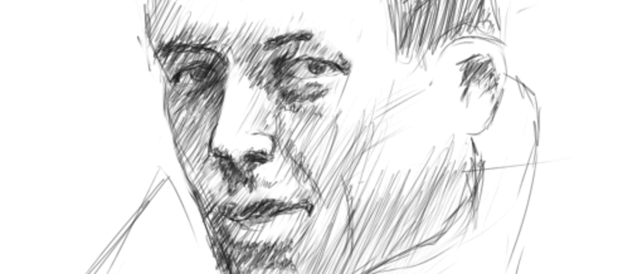

October 3, 2014
Image: sketch of Albert Camus, by Petr Vorel
Just two years ago, I was in the same position that many of you are in now, namely on the academic job market. The fall semester is under way and, in addition to dissertation work and teaching obligations, you have to write and revise some dense documents for your job applications. Those documents, far from conversational in tone, have to represent your past five to eight (or more) years of academic work in a clear, compelling, articulate, elegant way that demonstrates your unique contributions to your field. And you should have finished your other dissertation chapter. And your dishes are dirty. And you have run out of socks.
I found crafting a “statement of teaching philosophy” particularly elusive. What is it exactly, I wondered, and how does one write such a statement? Should the tone be philosophical, practical, entertaining, or some combination of all three?
I decided to approach the task by conducting some preliminary research. But after asking other students and professors about these statements, I received such a variety of answers that I decided to look at samples for myself. I read teaching statements written by colleagues and friends alike, as well as others that had been posted on web sites, and I studied the chapter on teaching statements in my trusty guide, The Academic Job Search Handbook. Eventually, I closed the books, put away the samples, and tried writing my own teaching statement.
With that first mediocre version in hand, I walked into the Yale University Teaching Center to discuss my draft with Bill Rando, the center’s director at the time. Quietly, he read and reread my statement. Then he turned to me and simply said, “Tell me what you are trying to convey.” I realized I could not succinctly answer his question, and I told him so.
So we began to talk about teaching. I remembered my own experiences as an undergraduate. I remembered learning about distant parts of the world that had seemed unreachable before my initial courses on Francophone literature. I remembered reading beautifully written stories in another language; imagining all the people I could speak to and get to know now; marveling at the historical, cultural, political, and even economic stakes of language. As Bill and I talked, I was reminded of just how much there is to consider on the topic of teaching. More specifically, I began to remember those moments of discovery that had prompted me to pursue graduate studies in the first place.
With Bill’s help, I quickly saw that I was telling too much in my teaching statement and showing too little. Paragraph after paragraph came across as generic at best, and overbearing or pedantic at worst. Something I had become so convinced of through my own teaching of literature--namely the primacy of close examination of textual subtleties--was simply not coming through in my statement. It was prescriptive rather than descriptive, full of jargon and lacking in detail and precision. There was no suspense, no moment, no real sense of me as a teacher. Clearly I had to rethink my approach.
I left Bill’s office and took a long walk down Grove Street. When I returned home, I went over to my bookcases, looking for the books from an undergraduate seminar I had taught (in conjunction with a professor in our department) on Albert Camus and the postwar period. I pulled down all my books from that class and lined them up across my desk. I then began, at random, to read my notes in the margins. I looked through the passages I had marked up over the course of the semester, and I took my time, placing myself back in that classroom with my students. Ultimately, it was the description of the dying rats, those first harbingers of the plague in Camus’s La Peste, that beckoned me most.
And just like that, I began rewriting my teaching statement as a self-portrait, rather than as a treatise. One small part of my teaching--that moment with Camus’s La Peste--would have to stand for the whole. One moment would have to suffice. But I would describe that moment in as much detail as memory, skill, and word count would allow. Soon I was recalling class discussions about specific passages of the book; theoretical questions about how it is that one reads, and why; what reading is; how language functions; the problematics of translation; and the complexities of genre, reception, and national identity. My statement became more concrete and evocative. I was showing, rather than telling.
I see now just how powerfully a moment in the classroom stands apart in a self-portrait of teaching. In clear, specific, memorable ways, that moment can suggest the tone of the classroom, the place of the text, the lessons to be gleaned, and the questions being investigated. It shows the teacher with the students and tells the story of a group of people grappling with uncertainty, creating meaning as a unit, moving together in a rhythm they define and redefine, functioning as several parts of one whole.
Finding that moment meant doing away with vague statements about what teaching is, should be, or how it works in the abstract. Rather, I needed to go back to the seminar room where the students and I met each week. I needed to set the scene--there I was, with fourteen undergraduates, sitting around a rectangular table, one day comparing the various editions of The Stranger in both English and French. Another day, we were thinking about Camus’s eerie, dramatic, absurd description of the diseased rats and their fantastical, theatrical pirouettes. In another moment, we were exploring the import of the historical, cultural, and political contexts in which the book was written and in which it has been received and interpreted. We were noticing the details and nuance of word choice, subject matter, the said and the unsaid, the beautiful and the grotesque, the interactions among content and aesthetic.
From that moment, and all it stood for, my portrait moved to a more general description of my teaching background, experiences, preparation, and methodology, before concluding with another nod toward The Plague. Ultimately, I pirouetted back to the text.
And now, job candidates, let us return to you as you write your own statement. A year ago, not long after I had accepted an academic position myself, I participated on a search committee and read many teaching statements from the “other side of the table.” Many of them rather quickly started to blend together in my memory. On the other hand, some stood out: the ones that were specific, that told a story, and that left me with a clear sense of the candidate as a teacher. I left those few statements with an image and feeling in mind; the candidate’s self-portrait had made its mark.
I’ll end, then, with this advice: As you work and rework, crafting and finessing your self-portrait in teaching, I hope you can take time to remember, in glorious detail, a moment or two in your own classroom. And then tell your future employers what happened, what you and your students encountered that day, what you resolved and concluded and how, and what questions remained. Paint the portrait. And good luck in your search.
(See the weblink for her actual teaching statement.)
https://chroniclevitae.com/news/734-teaching-statement-as-self-portrait?cid=VTEVPMSED1

