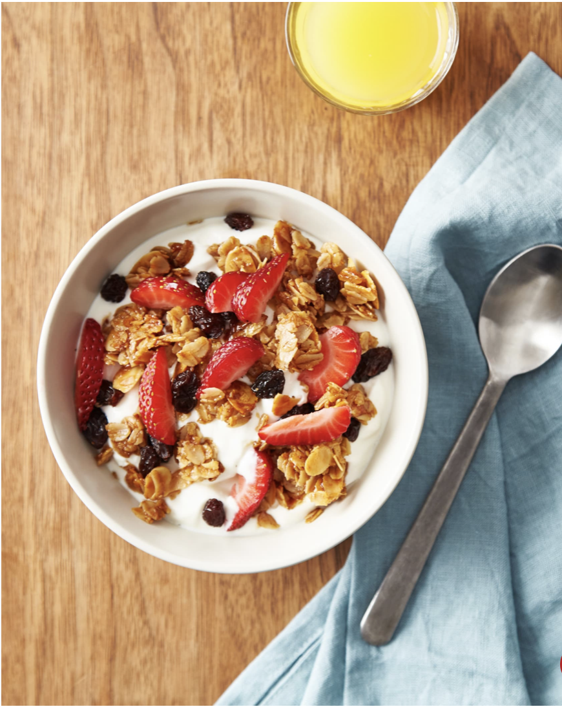
Breakfast Granola
Prep time: 15 minutes
Cook time: 20-25 minutes
Servings: 10
Serving size: ½ cup
Ingredients:
- 3 cups oats (rolled/old fashioned, or quick oats can work)
- ½ cup oil (olive, coconut, or canola)
- ½ teaspoon salt
- ½ cup honey or maple syrup
- ½ teaspoon ground cinnamon
- Fresh, dried, or canned fruit, to serve
- Milk or yogurt (dairy or non dairy), to serve
Optional Ingredients (not typically offered at cougar pantry, but may help enhance flavor):
- ¼ cup chopped nuts
- ¼ cup seeds (chia, flax, hemp, ect.)
- ¼ cup shredded coconut
- ¼ cup chocolate chips
Directions:
- Preheat the oven to 300 degrees. Line a baking sheet with parchment paper or line with oil.
- Whisk together oil, honey or maple syrup, cinnamon, and salt in a large bowl. Add oats to the mixture and mix well. If adding nuts and/or seeds, add with the oats.
- Transfer the mixture to a baking sheet and spread evenly. Place in the oven for 20-25 minutes, and mix halfway through.
- Once the granola is done cooking, mix in dried fruit, chocolate chips, and/or shredded coconut. Serve with yogurt or milk, and top with fruit. You may also eat it with a smoothie or by itself as a snack!

This breakfast granola is a great breakfast option because oats contain healthy carbohydrates to keep your energy levels high. Fiber, which is present in oats, fruits, and nuts, works to keep you fuller for longer while also promoting a healthy digestive system. Granola is a fun recipe idea because it can be made and served in a number of different ways. You can try serving it with milk, yogurt, smoothies, icecream, or as is! You may also have fun with this recipe by switching up the ingredients used. Feel free to customize this recipe to accommodate your taste buds!
Adapted from: https://www.thekitchn.com/granola-recipe-258376

