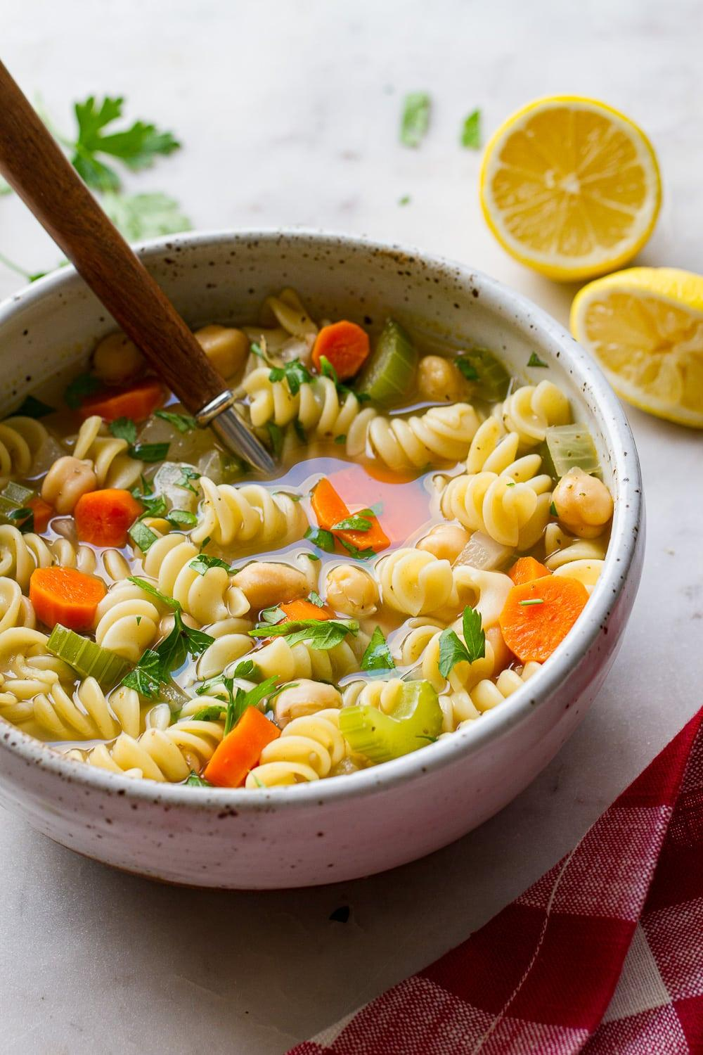
Noodle & Bean Soup
Prep time: 10 minutes
Cook time: 20 minutes
Servings: 6
Ingredients:
- 1 tablespoon of olive oil
- 1 onion, diced
- 3 large carrots, peeled and diced
- 3 ribs celery, sliced
- 2 cans cannellini or great northern beans
- 12-16 ounces of rotini pasta
- 10-12 cups vegetable broth
- Salt and pepper, to taste
Optional Ingredients (not typically offered at cougar pantry, but may help enhance flavor):
- 1 teaspoon thyme, basil, and/or oregano
- ¼ cup chopped fresh parsley
- Lemon wedges, to serve
Directions:
- Heat oil over medium in a large pot. Add carrots, onion, celery, and herbs. Cook for 5 minutes while stirring frequently.
- Add vegetable broth, pasta, and beans and bring to a boil. Once boiling, reduce heat to a simmer for 7 minutes.
- Add parsley and lemon, if desired, and stir.
This soup is a warm and filling meal that can be eaten for lunch or dinner. Carrots and celery are often offered at the fresh markets on a regular basis. Carrots are rich in vitamin A, which can help improve your eyesight, support a healthy immune system, and may lower your risk of certain cancers. Celery contains vitamin K, which can help protect against blood clots and help maintain bone health. Serve with crackers or bread, if desired.

Adapted from: https://simple-veganista.com/chickpea-noodle-soup/

