Classic Tuna Salad

Prep time: 15 minutes
Servings: 5
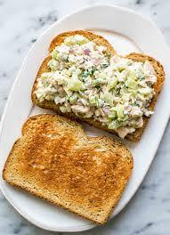
Serving size: ½ cup

Ingredients:
- 2 ½ 3-ounce packages/cans of tuna
- ¼ cup mayo (or Greek yogurt for Waldorf Salad)
- ½ teaspoon kosher salt or to taste
- Black pepper, to taste
- 2 tablespoons lemon juice (~1 lemon), optional
- 2 Tbsp pickle relish, optional
- ¼ cup diced celery (~2 ribs), optional
- ¼ cup red onion, chopped, optional
- Pitas, bread, rice cakes, or crackers for serving
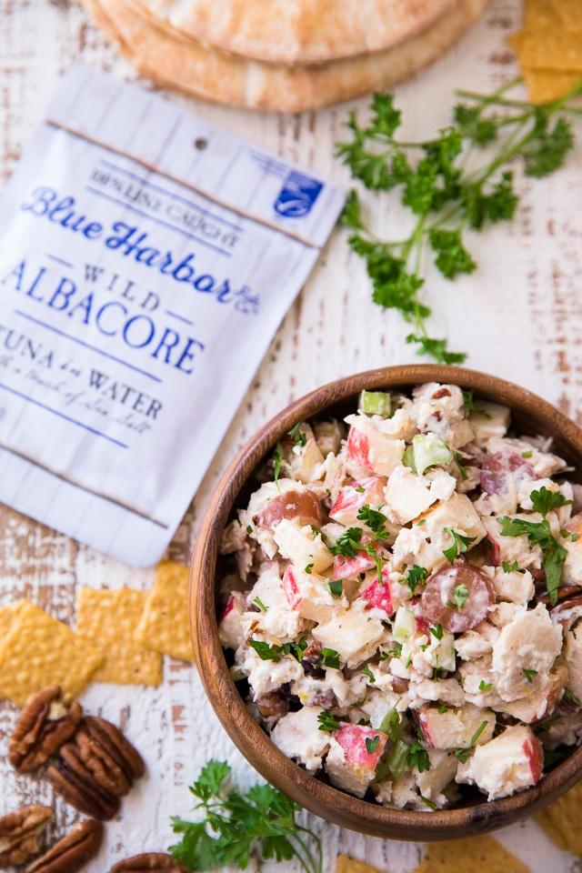
→ OR mix in with your favorite pasta!
Waldorf Tuna Salad
*Add these optional items for a sweet Waldorf salad. Fresh celery and fruits provide crunchy, crisp and refreshing textures while lemon juice adds acidity, tang, and enhanced flavor!
Additional Ingredients:
- ¼ cup diced celery (~2 ribs), optional*
- ½ medium apple, cubed, optional*
- ¼ cup red seedless grapes, halved, optional*
- ⅛ cup chopped or sliced nuts, optional*
- 2 tablespoons lemon juice (~1 lemon), optional*
Directions:
- In a large bowl, combine all desired ingredients and stir to combine. Eat immediately or let sit in the refrigerator for one hour. Serve both types of salads with pita bread, bread, rice cakes, or crackers. Keep salad for up to 5 days.

Enjoy these salads for lunch, dinner or as a refreshing afternoon snack. They are delicious when eaten with crackers, made portable as a sandwich or on a rice cracker, or can be mixed in with your favorite pasta! Tuna is packed with healthy fats like omega-3 that helps with anti-inflammatory effects, heart and eye health. Omega-3s also improve mood, fight depression and improve cognitive effects on the brain. B vitamins and iron-rich sources help with boosted blood circulation while providing energy to fuel your day. The classic tuna salad is great if you're feeling simple and want salty flavors. Try the Waldorf Salad recipe when you're craving sweeter flavors and crisp textures. Make it however you please- these recipes will not disappoint!
Recipes adapted from: https://www.culinaryhill.com/classic-tuna-salad-sandwich/ & https://www.kimscravings.com/waldorf-tuna-salad-pitas/

