Chicken Salad Sandwich

Prep time: 15 minutes
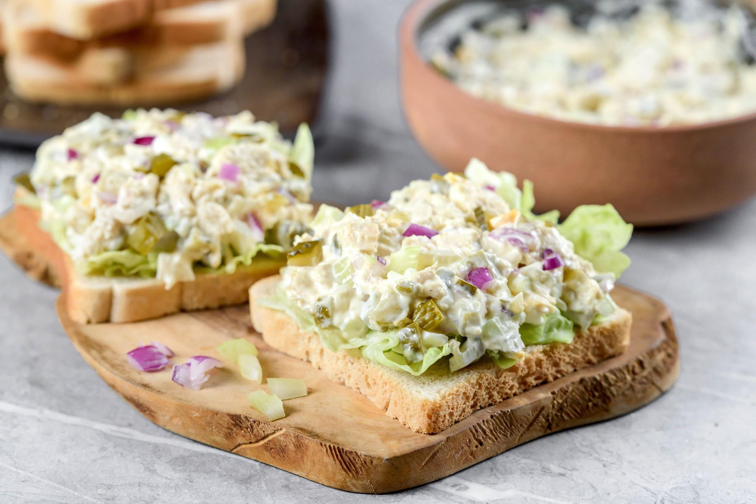
Servings: 4
Serving size: ½ cup

Ingredients:
- 1 ½ cups of canned chicken
- ½ cup celery, chopped
- ⅓ small onion, finely chopped
- ½ cup mayonnaise
- ¼ teaspoon kosher salt or to taste
- ¼ teaspoon black pepper, to taste
- Pitas, bread, croissants, rice cakes, or crackers for serving
→ OR mix in with your favorite pasta!

Optional Add-Ins:
- 2 tablespoons lemon juice (~1 lemon), optional
- 2 Tbsp pickle relish, optional
- 2 tablespoons dried cranberries or fresh grapes, optional
- 1-2 lettuce leaves, optional
- Sliced tomato, optional

Directions:
- In a medium bowl, mix all ingredients except grain (bread, crackers, pitas, pastas, etc). Adjust ingredients to taste and add any optional ingredients. Top salad with remaining bread.

Chicken salad sandwiches are an easy recipe that are perfect as a snack, lunch or dinner. They are delicious when eaten with crackers, made portable as a sandwich or on a rice cracker, or can be mixed in with your favorite pasta! Chicken is high in protein and helps keep you full and satiated throughout the day. It also helps with muscle and tissue repair- important for after you have a hard practice. Sodium and potassium found in chicken also help to replenish important electrolytes that are lost during workouts. Fiber from the celery, onions and bread (or other whole grain) also adds bulk, keeps you full, helps stabilize blood sugar and is a healthy mix of vitamins and minerals such as vitamin C, vitamin B6, folate, manganese and potassium. Take it on the go, or enjoy it at home.

Recipes adapted from: https://www.bettycrocker.com/recipes/chicken-salad-sandwiches/e19402ff-608a-4e4a-98b5-0cd6ee845b92

