The Chef’s Hot and Cold Cubes
You may have learned some rules for doing arithmetic with positive and negative numbers. Many people find these rules hard to remember and don’t understand where the rules come from.
The following mythical story provides a context for understanding how positive and negative numbers work. Many people find it easy to remember the story many years after they first heard it, and the memory of the story enables them to reconstruct the rules. The story also helps some people make sense of the rules.

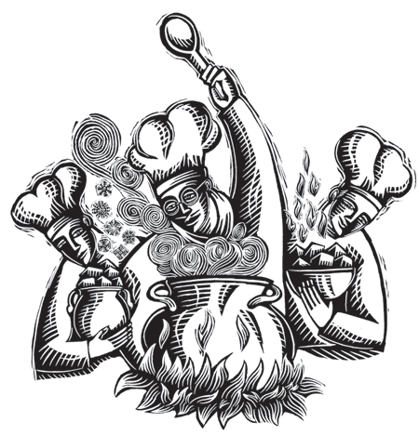
The Story
In a far-off place, there was once a team of amazing chefs who cooked up the most marvelous food ever imagined.
They prepared their meals over a huge cauldron, and their work was very delicate and complex. During the cooking process, they frequently had to change the temperature of the cauldron in order to bring out the flavors and cook the food to perfection.
They adjusted the temperature of the cooking either by adding special hot cubes or cold cubes to the cauldron or by removing some of the hot or cold cubes that were already in the cauldron.
The cold cubes were similar to ice cubes except they didn’t melt, and the hot cubes were similar to charcoal briquettes, except they didn’t lose their heat.
If the number of cold cubes in the cauldron was the same as the number of hot cubes, the temperature of the cauldron was 0° on their temperature scale.
For each hot cube that was put into the cauldron, the temperature went up one degree; for each hot cube removed, the temperature went down one degree. Similarly, each cold cube put in lowered the temperature one degree and each cold cube removed raised it one degree.
The chefs used positive and negative numbers to keep track of the changes they were making to the temperature.
For example, suppose 4 hot cubes and 10 cold cubes were dumped into the cauldron. Then the temperature would be lowered by 6° altogether, since 4 of the 10 cold cubes would balance out the 4 hot cubes, leaving 6 cold cubes to lower the temperature 6°. They would write
⁺4 + –10 = –6
to represent these actions and their overall result.

Similarly, if they added 3 hot cubes and then removed 2 cold cubes, the combined result would be to raise the temperature 5°. In that case, they would write
⁺3 – –2 = ⁺5
And if they wrote –5 – ⁺6 = –11, it would mean that first 5 cold cubes were added and then 6 hot cubes were removed, and that the combined result was to lower the temperature 11°.
Sometimes they wanted to raise or lower the temperature by a large amount, but did not want to put the cubes into the cauldron one at a time. So for large jumps in temperature, they would put in or take out bunches of cubes.
For instance, if the chefs wanted to raise the temperature 100°, then they might toss five bunches of 20 hot cubes each into the cauldron instead of 100 cubes one at a time. This saved a lot of time because they could have assistant chefs do the bunching.
When the chefs used bunches of cubes to change the temperature, they used a multiplication sign to record their activity. For example, to describe tossing five bunches of 20 hot cubes each into the cauldron, they would write
⁺5 • ⁺20 = ⁺100
where the ⁺5 meant that five bunches were being added, and the ⁺20 showed that there were 20 hot cubes in each bunch.
The chefs could also change the temperature by removing bunches. For example, if they removed three bunches of 5 hot cubes each, the result was to lower the temperature 15°, because each time a bunch of 5 hot cubes was removed, the temperature went down 5 degrees. To record this change, they would write
–3 • ⁺5 = –15
where the –3 meant that three bunches were being removed, and the ⁺5 showed that there were 5 hot cubes in each bunch.
- Each of the problems below describes an action by the chefs. Figure out how the temperature would change overall in each of these situations and write an equation to describe the action and the overall result.
  - Three cold cubes were added and 5 hot cubes were added.
  - Five hot cubes were added and 4 cold cubes were removed.
  - Two bunches of 6 cold cubes each were added.
  - Four bunches of 7 hot cubes each were removed.
  - Three bunches of 6 cold cubes each were removed.
- Describe the action involving hot or cold cubes that is represented by each of the following arithmetic expressions and state how the temperature would change overall.
  - ⁺4 – –3
  - –6 + –4
  - –10 • –5
  - ⁺4 • –8

