How Much Can They Drink?
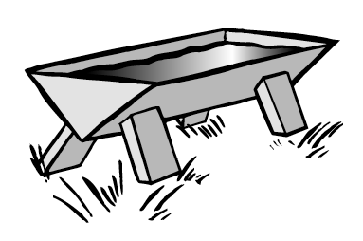
Farmer Minh built a drinking trough for his animals that had a triangular cross-section, as shown here. Unfortunately, that trough eventually wore out, and he has decided to replace it with one having a rectangular cross- section.
He has a sheet of metal that is 40 inches wide and 80 inches long. His plan is to bend the sheet along two lines parallel to the 80-inch side, to make a U-shape that will form the bottom and the long sides of the trough. He’ll use some other pieces of metal for the two ends.
For example, he might mark the sheet with two lines that are 5 inches from each 80-inch edge. These are the dashed lines shown below.
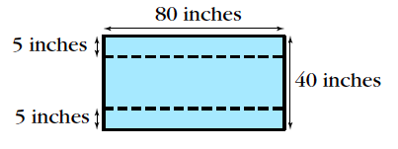
Then he would bend up the 5-inch-wide sections, to form a shape like the one shown below. Finally, he would attach pieces at the ends to complete the structure.
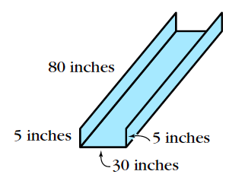
The completed trough might look like the picture shown here. In this case, the trough would be 30 inches wide, 80 inches long, and 5 inches high.
Farmer Minh wants to maximize the volume of water that the trough will hold. Can you help him?
- Find the volume of the trough with the rectangular cross-section as just described. That is, find out how much water this trough would hold if it were full.
- Find the volumes for two other troughs farmer Minh could make this way, using dimensions other than 5 inches for the width of the sections being bent up.
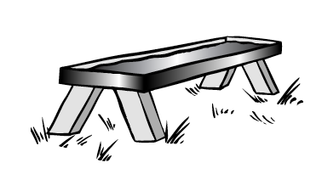
- Find a formula for the volume of the trough if the sections he bends up on the sides each have a width of x inches.
- By guess-and-check, find the value of x that will make the volume a maximum.
- Think about how you would write the formula from Question 3 in vertex form.

