Healthier Eating On & Around Campus: CSUSM

* Denotes a healthy meal choice for pre-workout/competition (2-4 hours prior)
** Denotes a healthy snack choice for pre-workout/competition (30 min-1 hour prior)
*** Denotes a healthy meal or snack choice for post-workout/competition

Coffee Cart- in front of Academic Hall
- Fresh bananas, oranges and apples **
- Cliff and power bars **
- Nature Valley granola bars
- Iced teas, unsweetened
- Chobani yogurt ***
- String cheese & cheddar sticks ***
- Fresh salads, dressing on the side
- Fresh Fruit Smoothies
- Sandwiches from Tina’s Deli- */***
  - Whole Wheat bread, Chicken salad/turkey
  - Hold the Mayo
- Coffee-
  - Keep pumps of syrup to a minimum
  - Low fat milk, soy milk
- Mixed nut packages- pay attention to serving size! **

Vending machines
- Toasted veggie chips (Wheat thins) *
- Mixed nut packages / trail mix ***
- Almond crunch packets ***

Market at the Union C-Store
- Pop chips, pretzels & popcorn
- Nutrition bars- watch sugar/ avoid artificial sugars **
- Yogurt ***
- Hummus packs
- Fresh fruit **
- Salads (watch dressings – aim for lower fat content)
- Sandwiches- lite/no mayo */***
- Lean Cuisine
- Lean Pockets
- Jerky

Jamba Juice
- Fresh fruit smoothies, opt for 16 ounce portions
- Consider adding a protein boost to help keep you stay fuller, longer
- Avoid sherbet in classic smoothies – opt for all fruit and juice

Caliente
- Choose grilled chicken vegetarian options; add guacamole for healthy fats
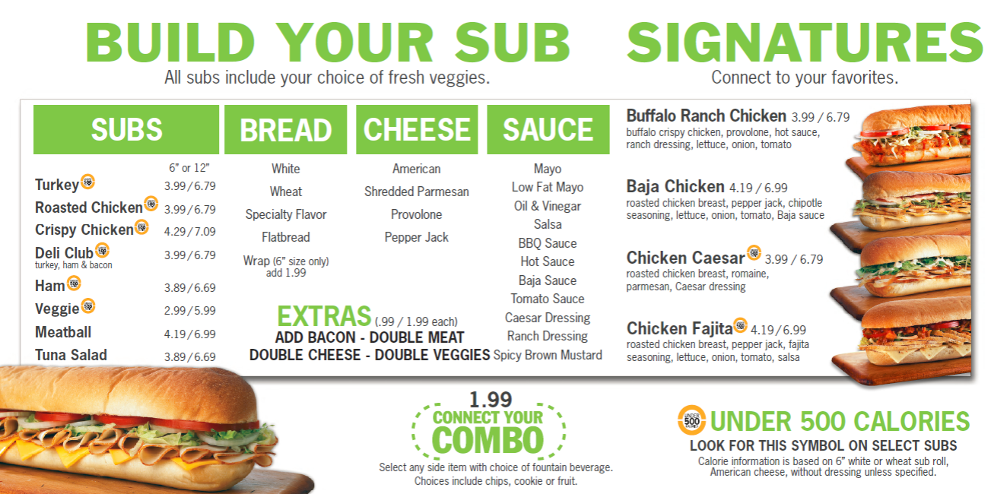
WOW Café
- Chicken Biscuit
- Sausage Biscuit
- Scrambled Eggs
- Biscuits and Gravy
- Side salad
- Covington Salad
  - Balsamic vinaigrette
- Grilled Chicken Sandwich
- Garden Fresh Quesadilla
- West Coast Veggie Wrap
- Veggie Burger
- Red beans and rice
- Sweet Potato fries
- Honey Mustard Slaw
- Chicken and Sausage Gumbo

Sub Connection
- Build your own salad
  - Order dressing on side
- 6” sub sandwiches, opt for ham with veggies, turkey and cheese, and mixed veggie subs, add a bag of Sun Chips and a cup of water

Panda Express

*Avoid fried or heavily breaded items
(Wok smart options have 300 calories or less and at least 8g protein)
- Sides: Steamed white/brown rice, mixed vegetables
- Broccoli Beef
- Grilled Asian Chicken
- Grilled Teriyaki Chicken
- Mushroom Chicken
- Shanghai Angus Steak (with asparagus or string beans)

Jazzman’s Café and Bakery
- Chicken salad sandwich
- Berry Salad
- Caesar Salad
- Strawberry parfait
- Whole wheat bagel
- Bananas and Oranges **
- Mixed nut packages- Watch serving size! **
- Unsweetened Iced tea
- Coffee-
  - Keep pumps of syrup to a minimum
  - Consider milk alternatives (almond milk, etc.)

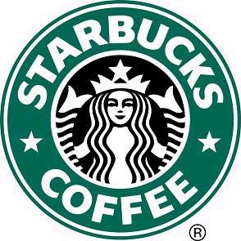
Starbucks

Healthier Snacks:
- Apple Bran Muffin **
- Parfait ***
- Sandwiches/***
- Wraps */***
- Dried or Fresh Fruit **
- Yogurt Parfait ***
- ½ Bagel (Multigrain, Whole Wheat, Plain, Blueberry, Sesame Seed) **
- Oatmeal **

Healthy Tips:
- Use milk alternatives
- Use fewer ‘pumps’ of syrup
- Hold the whipped cream
- Order Tall
- Limit “sugar free” options as this can make you hungrier later in the day!
- Increasing from a grande to a venti latte only increases the milk and sugar, not espresso. Instead of up-sizing, add an espresso shot to the smaller drink.

Examples of Pre- and Post- workout/competition meals/snacks
Pre-workout/competition meal examples (2 hours prior):
- Turkey sandwich from “The Dome”, light with mayo
- Big Cat Bistro low fat sushi rolls

Pre-workout/competition snack examples (30 mins – 1 hour prior):
- Coffee Cart fresh fruit or yogurt
- Starbucks muffins

Post-workout/competition snack example:
- Chocolate milk and piece of fruit
- Yogurt parfait (or just plain yogurt)

Post-workout/competition meal example:
- Healthy sandwich w/ chocolate milk
Healthy Eating Off-Campus: CSUSM

Subway
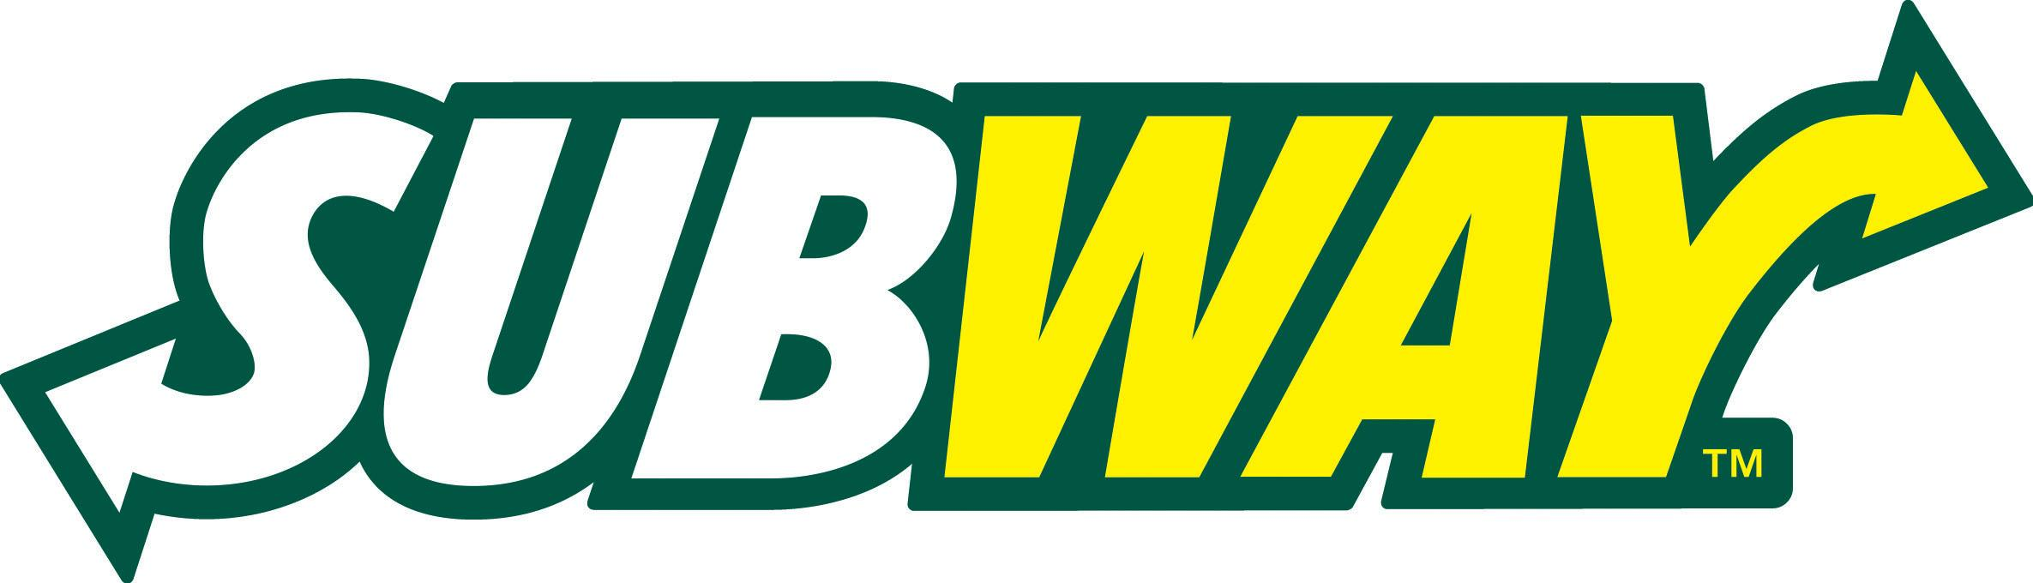
-Black forest ham */***
-Roast beef */***
-Subway Club */***
-Turkey breast */***
-Oven roasted chicken breast */***
-Baked chips **

Wings-N-Things
(Request for dressing on the side for all salads)
- Buffalo Chicken Salad
- Garden Salad

Chef’s Pho & Grill
*Avoid fried or heavily breaded items

- Spring rolls (shrimp, grilled chicken, veggie)
- Pho (chicken, grilled pork, seafood, tripe, steak)
- Soup (Veggie, beef, duck, crab, shrimp)
- Rice entrees; come with steamed rice, tomato slices, cucumber slices, and choice of protein (Grilled chicken, grilled shrimp, grilled pork & beef)

Flippin’ Pizza
*pay attention to serving size of dressing

- Side of oven roasted broccoli
- Garden salad
- Caesar salad
- Oh Baby Salad (Dressing on the side)
- Build your own personal pie or calzone with lots of veggies
- Garden pizza (sold by the slice)
- Add a side salad to calzone or pizza

Dickey’s Barbecue Pit
- Chicken breast or turkey plate (choice of 2 sides & a roll)
- Sides: Caesar salad, green beans, jalapeno beans, potato salad
- Turkey or Chicken breast sandwich
- Topping options: pickles, onions, jalapeno peppers
- Chicken breast & cheese taco
- Chicken spinach taco
- Turkey or chicken breast slider

Taqueria Chispa Mexican Grill
- Garden salad
- Chispa salad
- Azteca Salad
- Build your own taco, burrito (whole wheat tortilla) or bowl
- Protein options: grilled chicken, cactus, shrimp, potato, vegetarian, fish
- Toppings: pico de gallo, guacamole, cabbage, onion, salsa, cilantro, jalapeno,
- Sides: chips & salsa, white or brown rice, black beans, Peru beans, guacamole, garden salad, salsa fresca and chips & guacamole

Tapioca Express
(Some drink flavors may have up to 80g of sugar)

Drinks:
- Americano (limit the amount of sugar & creamer added)
- Teas
- Milk teas
Snacks:
- Fried String Beans
- Sausage

Urge Gastropub & Common House
- Spicy edamame
- Ahi Poke
- Soup & salad combo (add chicken, salmon, steak or ahi for protein)
- Seasonal vegetables
- Side salad
- Roasted Vegetable flatbread
- Urge Street tacos

Players Sports Bar
- Vegetable platter
- Chips & salsa
- Salad (dressing with fewer calories, dressing on the side)
- Sandwich on wheat bread (Swap mayo for avocado)
- Veggie Pizza
- Build your own pizza with lots of veggies and a bit of protein

Mr. Taco
-Low carb burritos: (choose whole wheat tortilla or spinach tortilla wrap)
-Salads:
- Cachanilla
- Grilled chicken salad
- Caesar salad (add chicken or beans for protein)
- Avocado green salad
-Soups: Caldo de Camaron (shrimp). Caldo 7 mares (7 seas).
-Breakfast plates: low-fat cheese on them

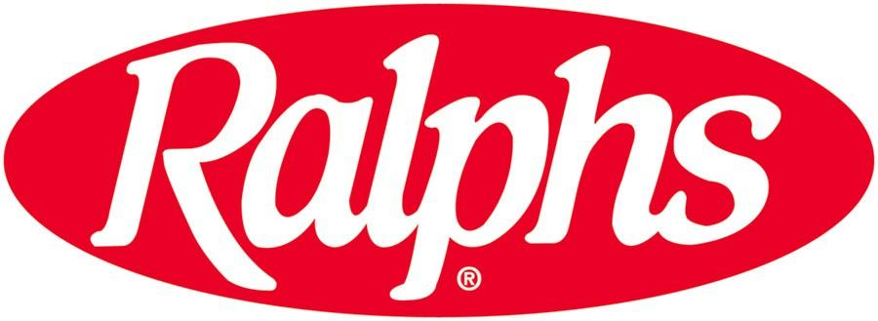
Ralphs Deli
-Any of their pasta options or fruit (around 1-1.5 cups) and
combine w/ lean deli meat (few slices) */***
- Deli sandwich w/deli meat */***
-Granola bar **
-Nutri-Grain Bar **

* Denotes a healthy meal choice for pre-workout/competition (2-4 hours prior)
** Denotes a healthy snack choice for pre-workout/competition (30 min-1 hour prior)
*** Denotes a healthy meal choice for post-workout/competition

Examples of Pre- and Post- workout/competition meals/snacks

Pre-workout/competition meal examples:
- Subway 6” Black Forest Ham on white bread w/ backed chips and water */***
- Prime Cut Grill Cajun pasta w/ water */***

Pre-workout/competition snack examples:
- Granola or Nutri-Grain Bar from Ralphs*

Post-workout/competition meal examples:
- Smoothie King’s The Shredder shake **
- Subway Oven Roasted Chicken Breast with baked chips, water */***

