PART I: Community @ CSUSM Account
- Read Steps 1-7 below before starting the enrollment process.
- To create an account, click on New Account form and scroll down to “Create New Account.”
- Fill out the form with your desired username and password.
- Enter your valid email address (to be used to confirm and complete the process).
  - You can use a personal email, or your university email.
- An email will be immediately sent to the email address you entered.
- Check your email from the email address you provided to receive a confirmation link.
  - Click the confirmation web link;
  - Click “Continue.”
- Your account will be confirmed and you will be logged in.

PART II: Course Enrollment

  - Go to the following page: https://community.csusm.edu/course/view.php?id=8850
  - This is the page for the “CSUSM Specialized Short-Term Program”
  - You might see the following message: “You are currently not enrolled in any courses.”
  - Click the X in the upper right to return to the Community homepage (but stay logged in).
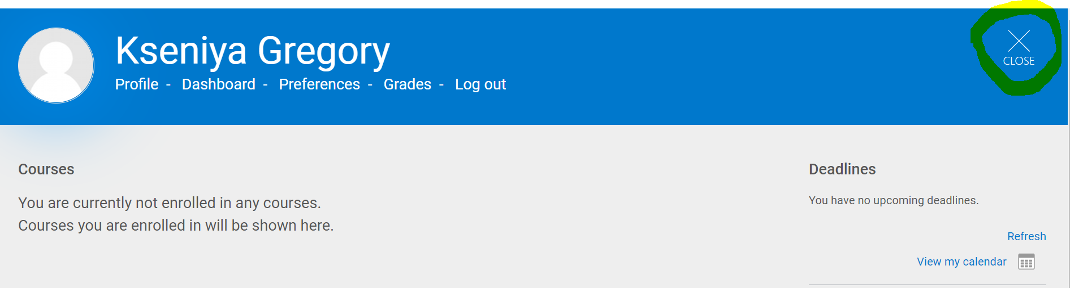
- Scroll to the bottom of the page.
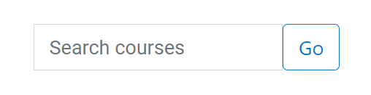
- In the Search Courses box, enter the name of the container (CSUSM Specialized Short-Term Program) and click Go.
- Click on the name of the course. You will see the following:
CSUSM Specialized Short-Term Program
Enrollment Key
- In the field that says “Enrollment Key” enter alci2022
    - All lowercase, no spaces or punctuation
- Congratulations: you are successfully enrolled in the course!

PART III: Future Course Access

Step 1: Go to https://community.csusm.edu
Step 2: Log in using the username and password you have created
Step 3: Click on the course “CSUSM Specialized Short-Term Program”

