The Garden Border
Leslie was planning an ornamental garden.
She wanted the garden to be square, 10 feet on each side, and she wanted part of this area to be used for a border of tiles. The tiles she wanted were each 1 foot by 1 foot square.
Leslie had to figure out how many tiles she needed.
Your challenge is to figure out how many tiles Leslie needed without counting the tiles individually. Write down as many ways as you can for doing this, giving the specific arithmetic involved in detail.
For each method that you find, draw a diagram that indicates how that method works.

Border Varieties
Leslie decided it would be nice to have a general formula for her border problem, giving the number of tiles needed as a function of the size of the garden.
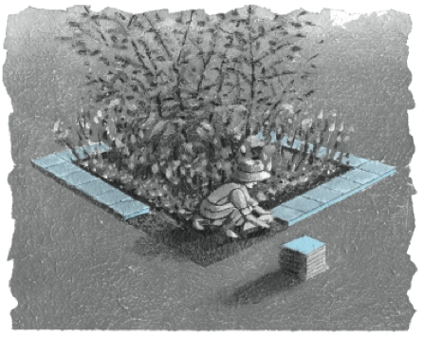 | She imagined a square garden that was s feet on each side, and continued to work with square tiles that were 1 foot on each side.  She asked for some help from students who had worked on the border problem for the 10-by-10 square. Since they had solved it in different ways, they also came up with different formulas for the general problem.
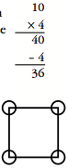
For example, one student had counted ten tiles along each edge, and then subtracted 4 because the corner tiles had each been counted twice. In other words, this student’s arithmetic looked like that shown at the right.
The student used the diagram at the right to explain this arithmetic and came up with the formula 4s - 4 for the general border problem

- Shown below is the arithmetic used by five other students in the 10-by-10 case, along with a diagram that each student used to explain the arithmetic.
For each of these methods, find a general formula that fits that student’s way of thinking about the problem. Your formula should use s to represent the length of one side of the garden. Make your formula match the arithmetic as closely as possible.
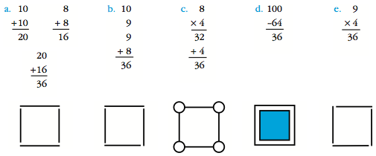

- Give the arithmetic, a diagram, and a general formula for another method of solving the border problem.

