Black Bean Breakfast Burritos
Prep time: 10 minutes
Cook time: 10 minutes
Servings: 1
Serving size: 4
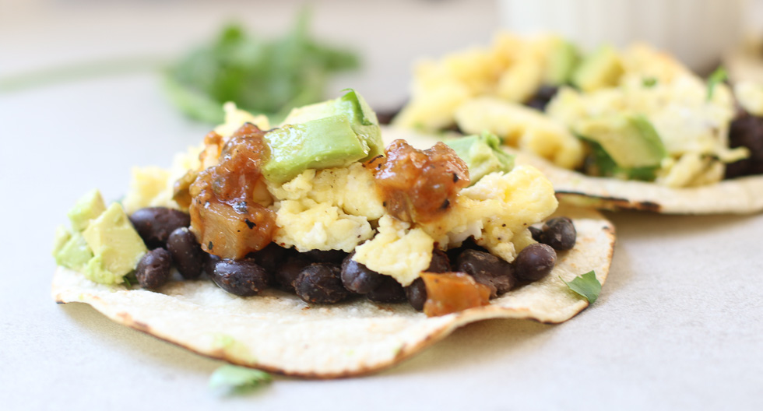
Ingredients:
- 8 6-inch tortillas, warmed
- 1 tsp olive oil
- ½ cup red onion
- 1 clove garlic or 1 tsp garlic powder
- 1 15-ounce can black beans, rinsed and drained
- 4 eggs
- ½ cup salsa or pico de gallo

Optional:
- ¼ cup chopped cilantro
- 1 small avocado or guacamole
- 1 dollop sour cream
- Sprinkled shredded cheese
- Diced jalapeno
- 2 slices bacon or turkey bacon

Directions:
- Scramble eggs.
- Heat oil in a large skillet over medium-high heat. Saute the onions until soft, about 3 minutes. Add beans and garlic (or garlic powder) until heated through, about 5 minutes.
- Blister the tortillas over a skillet until they start to bubble-then flip. Set aside, wrapped in a cloth napkin to keep them moist and warm.
- Layer the beans, then eggs onto each tortilla. Add desired toppings, such as avocado/guacamole, salsa, cilantro and cooked meat.

These black bean burritos are a delectable and warm breakfast that are perfect to fuel yourself in the morning or after those early morning practices. Fiber-rich sources such as whole grain tortillas, black beans, and vegetables help slow digestion to help with healthy morning blood balance regulation. Eggs and black beans are packed with vitamins, minerals, and are an excellent source of protein that aids in recovery and rebuilding muscle and other tissues. Top it off with some avocado to get healthy omega-3 fats, a type of anti inflammatory fatty acid important for your health and overall recovery.
Recipe adapted from: https://marisamoore.com/easy-black-bean-breakfast-tacos/

