Peanut Butter Oatmeal Breakfast Cookies
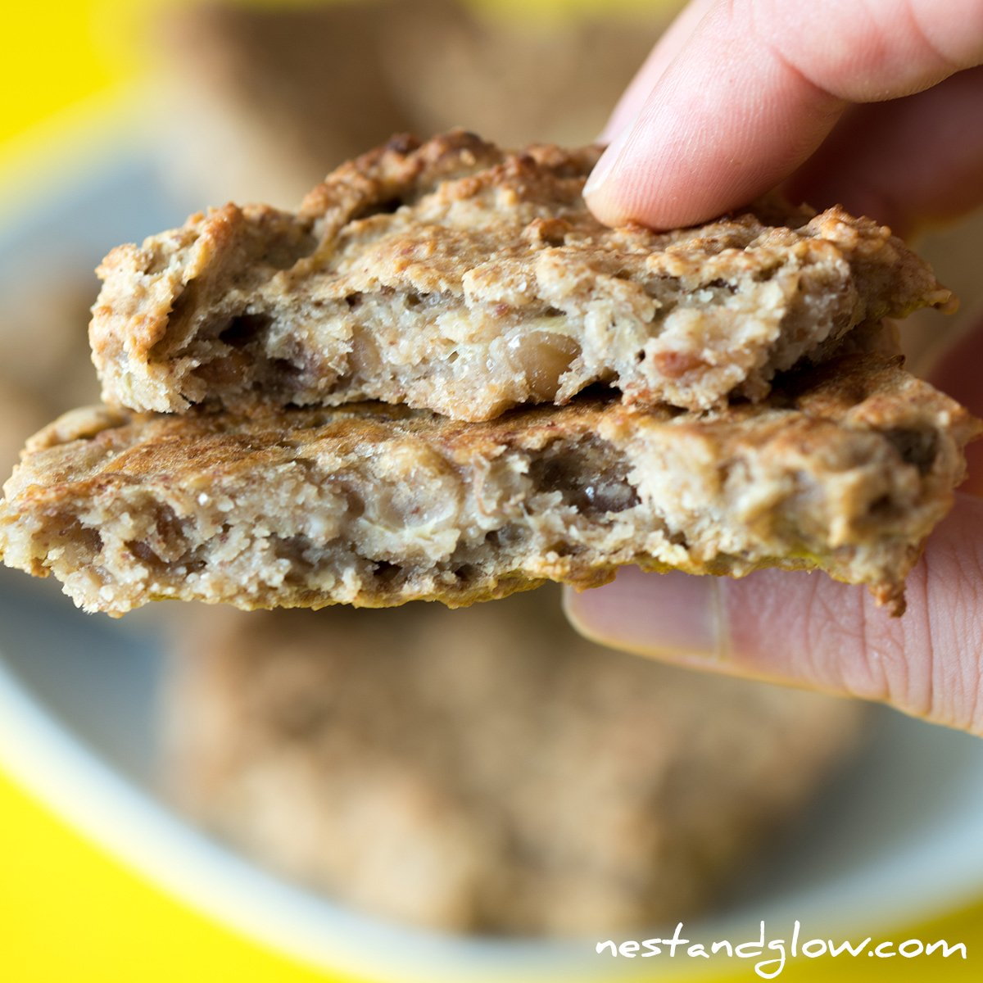
Prep time: 5 minutes
Cook time: 30 minutes
Servings: 6
Serving size: 1 cookie

Ingredients:
- 1 ½ cup oats
- 4 Tbsp peanut butter (creamy or crunchy)
- 3 large bananas
Optional add-in ingredients:
- ¼ cup chocolate chips
- ¼ cup dried fruit
- ¼ cup chopped nuts or seeds
- ¼ cup coconut shreds
Directions:
- Preheat oven to 375 degrees.
- Blend oats for a few seconds, until oats are finely ground.
- Peel and mash bananas. Put mashed banana and peanut butter with oats and mix well. Max mixture into 6 balls.
- Line a pan with oil or parchment paper. Place cookie dough on a pan. Use a fork to flatten out the cookies so that they will cook evenly.
- Place cookies in the oven for 20-30 minutes.
- Remove from the oven and enjoy.

These oatmeal cookies are simple and portable--perfect to bring on-the go! Eat these as a quick breakfast, snack, or dessert. You can alter this recipe with different types of nut or seed butters (almond butter, sunflower seed butter, cashew seed butter) and different types of oats (old fashioned oats, quick oats). Peanut butter contains protein, phosphorus, and magnesium to help support healthy bones and muscles. Peanut butter also has zinc and vitamin B6, which helps support immunity, and niacin which supports nerve function.

Recipe adapted from: https://www.nestandglow.com/healthy-recipes/peanut-butter-cookies

