Peanut Butter and Apple Toast
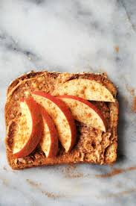
Prep Time: 5 minutes
Serving size: 1 slice
Ingredients:
- 1 slice toast
- 1 tablespoon of peanut butter
- 1 apple, sliced
Optional Ingredients (not typically offered at cougar pantry, but may help enhance flavor):
- 1 teaspoon of cinnamon
Directions:
- Toast bread. Slices apples in the meantime.
- Spread peanut butter on toast, and top with sliced apples and any other desired toppings.

This filling and nutrient dense meal can be eaten as a breakfast, or also as a snack! Apples can be found at the fresh markets, and contains antioxidants and fiber. Fiber helps you feel fuller longer, as well as promoting a healthy digestive system. Consuming foods with antioxidants can help reduce your risk of developing heart disease and certain cancers. Peanut butter and apple toast can be styled many ways, so feel free to have fun with it! Add jam, honey, or agave to the base of the toast with the peanut butter. You can add toppings to the toast like chia seeds, flax seeds, chopped nuts, dried fruit, or coconut flakes! The pantry also offers canned peaches or pears on a regular basis, which may be substituted with the apple.

Recipe adapted from: https://www.veganosity.com/simple-healthy-vegan-breakfast-toast-isnt-boring/

