Black Scholars: Explaining Your Work May Mean Fighting For It

Noliwe Rooks
Associate Professor, Africana Studies and Feminist, Gender and Sexuality Studies, Contributor at Cornell University
November 20, 2013

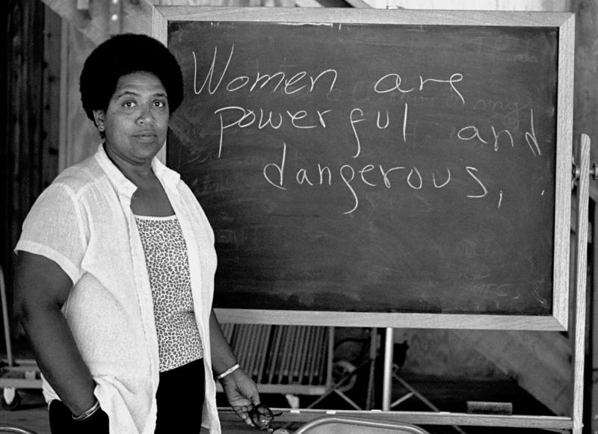
Photo: Audre Lorde in 1983. (Robert Alexander/Archive Photos/Getty Images)
"You have to be twice as good as them to get half of what they have." It’s a line familiar to many African Americans, but when the political fixer Olivia Pope delivered it last month in an episode of ABC’s Scandal, black Twitter and Facebook came to life anyway.
I couldn’t help thinking that it was resonant for academics, too. It’s not necessarily the case that “blackademics” have to put in twice as many hours of literal toil as others seeking promotion, tenure, and a successful academic career. But too often, we have to work twice as hard to convince powerful committee members that our scholarly work has value. This is especially true when our work touches on subjects that are controversial, challenge or—worse yet—almost completely foreign to those whose approval we need.
After almost 20 years in the highly racialized terrain of the academy, I know that support and consent are no small things. At most four-year institutions, fewer than 10 percent of professors are people of color, so when it comes to promotion and tenure, those professors aren’t often in positions of authority. The problem this creates is clear: If we aren’t able to convince the faculty powerbrokers we do have that the subjects we want to pursue, familiar or not, are worthy of support, we may not get as far down the road as we want to go.
Of course, race isn’t the only predictor of whether your research ideas will receive collegial support. But it’s a factor. Just consider the titles of some of the books that provide advice to black academics. There’s The Black Academic’s Guide to Winning Tenure—Without Losing Your Soul, which gives advice on negotiating the convergence of power and race in the academy. And there’s Presumed Incompetent: The Intersections of Race and Class for Women in Academia, which offers women of color strategies to help them "navigate the often hostile terrain of higher education."
Many of us choose to navigate that terrain because the new forms of scholarship we produce not only challenge the status quo, but also lead to changes in the very nature of who has the ability to define truth and knowledge. Nonetheless, there can be consequences for scholars of color who produce work that unsettles. Most are tied to the general difficulties of finding and then keeping academic jobs.
This is a reality with which I have had personal experience. When I was a Ph.D. student at the University of Iowa, I knew I wanted to write my dissertation on the politics of hair for black women in the United States. Though today there are a number of wonderful books, articles, blogs, and websites that attest to the cultural significance of hair, at the time there just wasn't much scholarly writing on the topic. I tried hard to convince my committee that it was a subject complex enough to explore in a dissertation, but was told the topic was too narrow.
Finally, I went to speak with a historian named Linda Kerber, who was from New York, wore her hair in what she described as a "jewfro," and had family members who had traveled to Harlem to have their hair styled. She understood the politics of black hair to be a richly complex topic with scholarly significance, and she was immensely supportive of my idea and my subsequent project. I was—and always will be—grateful to her for her support. But I couldn’t help but notice that it was her understanding and enthusiasm, not mine, that led my committee to finally embrace my scholarship.
Partially because of that experience, one of the things I tell students—graduate and undergraduate alike—is to "fight for it." When they struggle to express an idea, start to form an argument, or lose their footing as they defend their position, I tell them to push through their own hesitation and self-doubt. And I urge them to care enough about their ideas to keep reaching for a solution, a conclusion, or a reason why what they think matters.
That said, the contours of the battle can be made that much more difficult if the writer is of color, or female—especially if she is trying to convince a committee member or press editor that the experiences at the heart of her project are worthy of support. And yet expanding what counts as knowledge and focusing on the experiences of people who are underrepresented is an essential academic project. As the great Audre Lorde wrote in her 1984 classic text Sister, Outsider:
Those of us who stand outside the circle of this society's definition of acceptable women; those of us who have been forged in the crucibles of difference—those of us who are poor, who are lesbians, who are black, who are older—know that survival is not an academic skill.
Which is to say: Though we may have to work a bit harder, when we do our work well, the payoff is more than worth it.
Noliwe M. Rooks is an associate professor of African studies and feminist, gender, and sexuality studies at Cornell University. Among her books is White Money/Black Power: The Surprising History of African-American Studies and the Crisis of Race in Higher Education (Beacon Press, 2006).
https://chroniclevitae.com/news/168-black-scholars-explaining-your-work-may-mean-fighting-for-it?cid=chesectionpromo#sthash.o6diLwwv.dpuf

