Do It the Chef’s Way
Explain each expression in terms of the “hot and cold cubes” model. Your explanations should describe the action and state how the temperature changes overall.

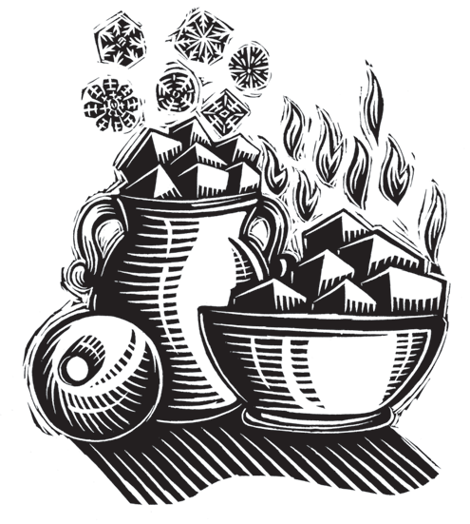
- -6 + -9
- -7 - -10
- +5 • -2
- -4 - +6
- +3 + -7
- -6 • +9
- -3 • -4
- +8 - -12
- -12 + +5

