Chili Pasta
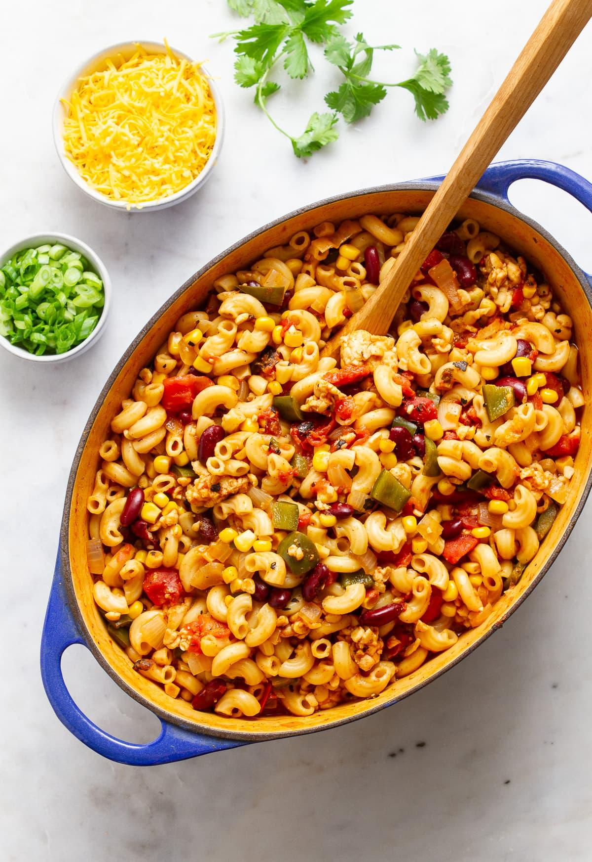
Prep time: 10 minutes
Cook time: 20 minutes
Servings: 6
Ingredients:
- 2 ½ cups elbow pasta
- 1 can red kidney beans, drained and rinsed
- 1 can sweet corn, drained and rinsed
- 1 can diced tomatoes or tomato sauce
- 4 and ¼ cup water or vegetable broth
- Salt and pepper, to taste
Optional Ingredients (not typically offered at cougar pantry, but may help enhance flavor):
- 1 large onion, diced
- 4 cloves garlic, minced
- 1 bell pepper (any color), seeds removed and minced
- 1 – 2 tablespoons chili powder
- 1 teaspoon cumin
- 1 teaspoon oregano
- 1 teaspoon paprika (smoked or regular)
Directions:
- In a large pot, heat ¼ cup of water in medium heat. Add peppers, onions, and garlic and saute for 5 minutes. add the chili powder, cumin, paprika, oregano and salt, cook 1 minute (if applicable).
- To the same pot, add pasta, beans, corn, diced tomatoes/tomato sauce, and the water/vegetable broth. Bring to a boil, then reduce heat to a simmer and cover. Leave on simmer for 10 minutes. Serve and add salt and pepper to taste.

This dish is a fun mix of chili and pasta! This meal can be made for lunch or dinner. It is perfect for busy students because you can combine all the ingredients in one pan and leave it to cook. Kidney beans are a great source of plant protein. When kidney beans are combined with pasta, the protein becomes complete and will help keep your muscles healthy. Tomato sauce will add flavor and texture to the dish, as well as improving heart health. This dish may be topped with cheese, scallions, sour cream, and/or cilantro. Recipe adapted from: https://simple-veganista.com/vegan-chili-mac/

