The Personal Touch: Using Anecdotes to Hook a Reader
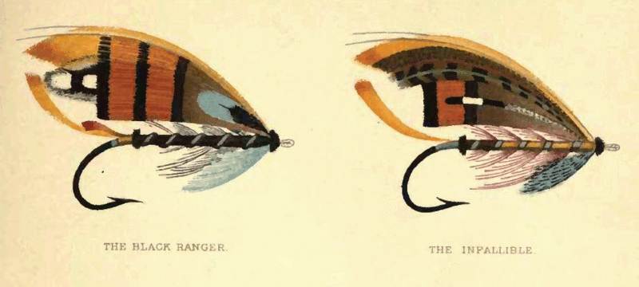
May 29, 2015
Image: Plate I from George M. Kelson's The Salmon Fly (1895)
Back when I was getting a degree in journalism, we spent so much class time talking about how to write a good “lede” that the subject should have been its own minor. We scribbled and rewrote our introductory paragraphs. We studied the openings of Pulitzer-Prize-winning stories, looking at the writer’s mechanics. The purpose: to drill into our neophyte heads that the lede is the single most important part of any story. Period. It’s where you grab your readers and it’s how you keep them.
Ultimately, there is only one basic rule to writing a great opening paragraph: “Don’t be snoozy.” (I stole this phrase from a former journalist, Will Harper, who once gave a lecture with this gem at its center.)
If you’re reading this, my guess is that you’re at least interested in writing op-eds or short essays for places like Slate, the Huffington Post, or The Wall Street Journal. You may already have a terrific idea and a topical subject. Because of your credentials and research, you’re probably the perfect person to write it. The only trouble: Op-eds and short essays are likely to get turned down in today’s saturated market. Competition is fierce and a lot of professional writers are your direct rivals for space.
One of the biggest reasons that an editor will pass on a scholar’s submission is – and prepare yourself for some tough love here – it’s more than a little boring. The writing is too dull, too dry, too navel-gazing, too “academic,” or it’s all four of those things put together. In other words, it’s not for a general audience. Editors can usually tell if they’ll accept your piece after reading your lede alone. It’s that important.
So if you have a timely topic for an 800-to-1,200 word nonacademic piece, and you want to grab an editor’s attention, the first thing you should be thinking about is the “hook” for your lede. Typically, it is a personal anecdote or something specific and compelling from your research. It should interest readers from the get-go and make them feel a connection to you or the topic.
Caution: Using short anecdotes, stories, or vignettes isn’t as easy to pull off as it might seem. The technique can backfire. If it isn’t done well, it can come off as rambling, self-absorbed, or even egomaniacal. What follows are some general tips for using the personal touch in the opening section of your essay.
Even if it’s about you, don’t make it all about you.
Using your own recollections, fieldwork, or research stories is a great way to introduce your topic and argument to a general audience. However, the story you’re telling – even if it’s your own personal experience – should not be only about you.
The trick is to make the “I” universal enough that readers can invoke themselves in the narrative. As critic Mark Athitakis warned in a recent essay in The Washington Post on memoirs, if you’re going to use yourself to tell us something, “just recognize that ‘I’ is the least important word in it.” Instead, try focusing on the importance of the moment or the event. What about this personal story is compelling for readers? The answer to that question will lead you directly to the next step.
Create a three-dimensional scene.
The trick is to universalize your personal anecdote through specifics. Think about why you want to use this moment in the first place. What details lend themselves to the argument you’re making in the rest of the piece? Your anecdote should set the stage for what’s to come.
List out all the sensations, thoughts, and actions that best capture the importance of the event to the larger theme of the piece. Then use those specifics to craft a full experience for readers. Take them with you into the scene. Were you cold? Great. Mention your thin sweater. Were you scared? Tell them why.
In a piece I recently wrote for Slate, I used small details to set the scene: “While I waited in my thin, blue paper gown, I started searching on my smartphone for any relevant medical information. I was busy feverishly bookmarking pages explaining the different types of breast masses when the radiologist finally called me into her office.”
Many of us have vivid memories of having worn those paper gowns, so that tiny description does a lot of work for me. It evokes the memories of my readers and puts them in the room with me. They may think about whether or not they would also be looking up information on their smartphones. It creates a shared experience that I can then use in my next paragraph to make my larger point about medical information.
Tack back and forth from your experience to your argument and evidence.
An anecdote works best when it is threaded throughout the entire piece. The tone of an essay is set by the anecdote – so your writing should remain somewhat “conversational” throughout. Even when you’re making important points or highlighting the latest research, be clear and concise.
Don’t dumb anything down, but be more cogent and transparent than you might otherwise be in a scholarly article. You won’t have much space for “nuance,” counterpoints, or caveats. Those types of arguments are what you give up when you’re trying to reach a broad audience. To keep to 1,200 words, you only get to make one main argument using one main anecdote to highlight it.
End with a “callback.”
An effective way to end is with a reflection on where you began. In comedy terms, gesturing back to the beginning is known as a callback and it works. In writing for a nonacademic audience, the mirror effect works to show readers that you weren’t just navel-gazing in sharing your personal story. The callback should highlight what you learned from the experience and how that ties back into your overall argument.
A final note for those academics and graduate students new to op-ed and short-form writing: Learning to write for general audiences is difficult. In a long process peppered with rejections, it helps if you start to read a lot of op-eds and short essays with a writer’s critical eye. Start spotting the techniques that work for other authors and then mimic them in your own work.
Theresa MacPhail is an assistant professor in the Science, Technology & Society Program at Stevens Institute of Technology.
- See more at: https://chroniclevitae.com/news/1019-the-personal-touch-using-anecdotes-to-hook-a-reader#sthash.xBN1W2nM.dpuf

