Pasta Shells with Spinach and Cannellini Beans
Prep Time: 5 minutes
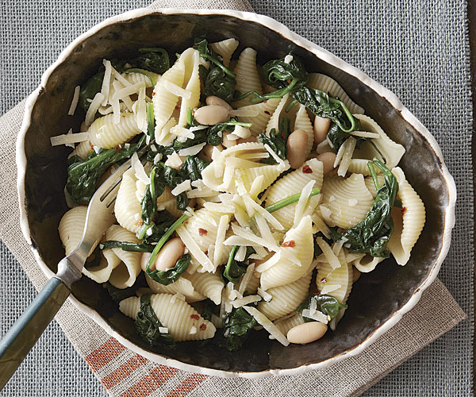
Cook time: 20 minutes
Servings: 4-6
Ingredients:
- 1 lb pasta shells
- 1 19 oz can of cannellini beans, drained and rinsed
- 2 cans of spinach (9 packed cups of fresh spinach)
- ¾ cup chicken broth or water
- 3 tablespoons olive oil, more for serving (If desired)
- 1 teaspoon salt
Optional Ingredients (not typically offered at cougar pantry, but may help enhance flavor):
- 2 tablespoons lemon juice
- ½ teaspoon crushed red pepper flakes
- 3 cloves garlic, minced
- Grated parmesan cheese, to taste
Directions:
- Bring water to a boil. Cook pasta according to package directions.
- Meanwhile, heat 2 tbsp olive oil in a skillet over medium-low heat. Add minced garlic to the skillet (if applicable) and cook for about 30 seconds. Add spinach, and cook for about 3 minutes. Then, add the beans and chicken broth (or water). Increase heat to medium-high and cook while occasionally stirring for 2 minutes. Add pepper flakes and salt , then bring to a simmer.
- Once the pasta shells are done, drain and keep ½ of the pasta water. Pour the pasta into the skillet, and add the remaining 1 tbsp olive oil and lemon juice. Add a little bit of pasta water at a time, only if necessary to moisten the dish.
- Serve with extra olive oil, salt, lemon juice, and grated parmesan cheese. Enjoy!
Recipe adapted from: https://www.finecooking.com/recipe/pasta-shells-with-spinach-and-cannellini-beans

This pasta dish with spinach and cannellini beans is a great lunch or dinner option, because it is filling and nutritious! Cannellini beans are a good source of protein, and pasta is a good source of carbohydrates. Protein helps us maintain healthy skin, immune function, and muscle tissues. Carbohydrates are the body's main source of energy. Spinach is rich in iron and vitamin K1, which helps improve blood health. Spinach is also a good source of calcium, which helps with bone, muscle, and nervous system health. Feel free to change the type of pasta being used, this dish can work with any shape!

