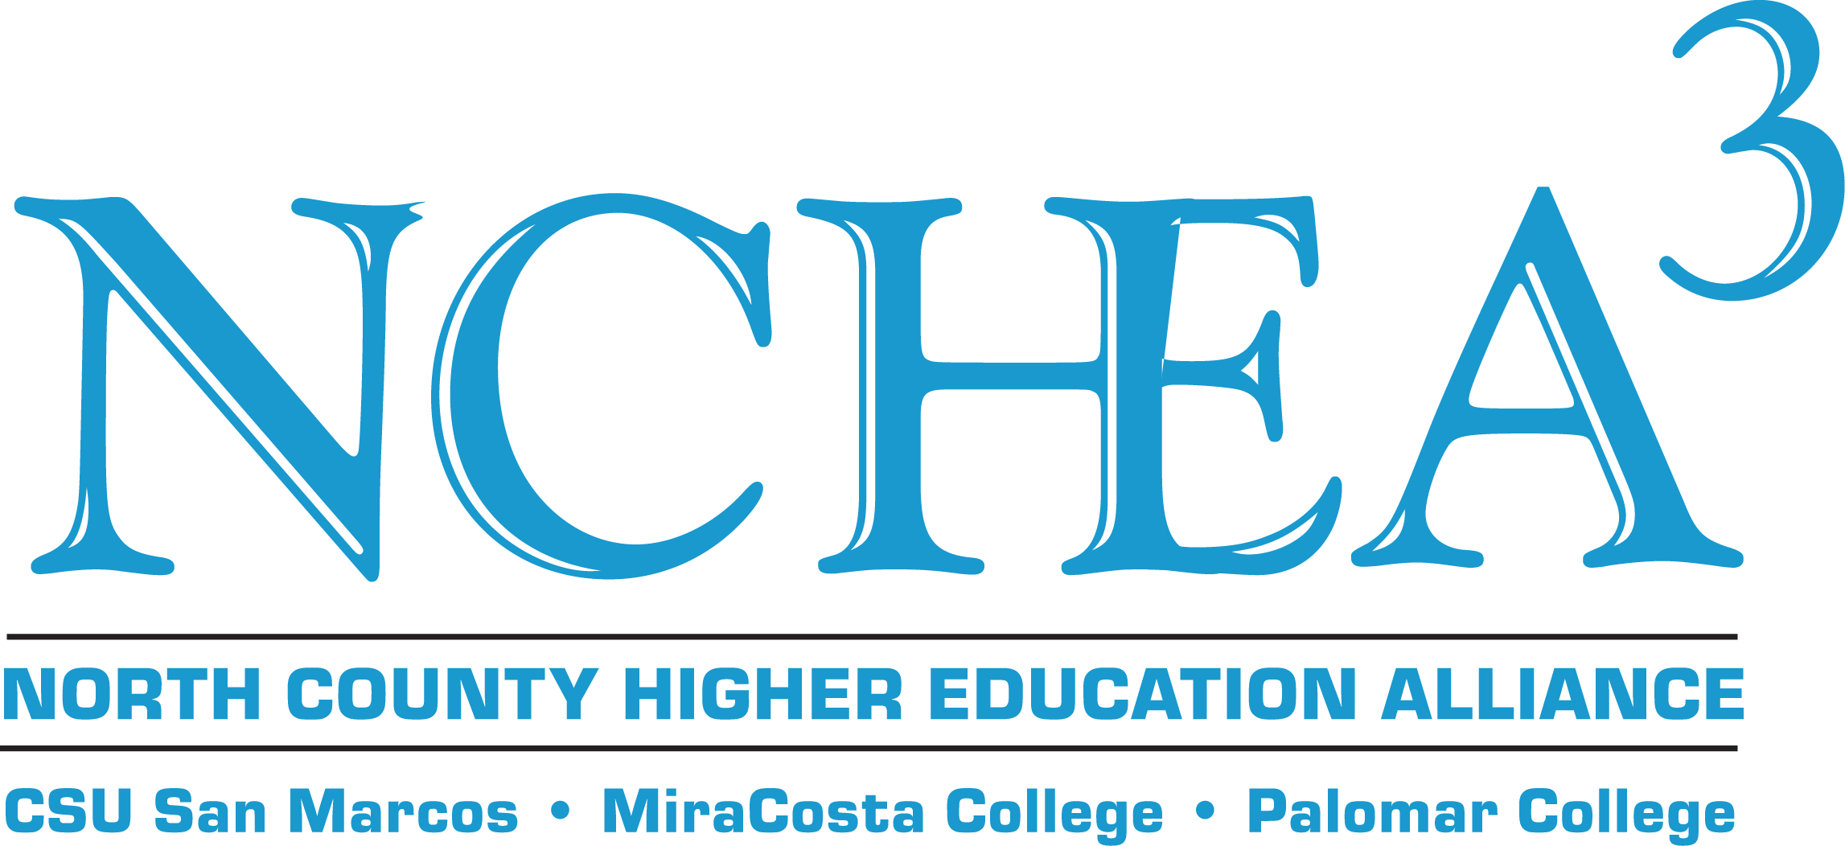

Spring 2015
GRANT ANNOUNCEMENT
Application Deadline: Thursday, April 9, 2015, by 5:00 pm.
For priority consideration please submit by February 12, 2015, by 5:00 pm.

The North County Higher Education Alliance (NCHEA) is accepting applications for funding projects involving the collaboration of colleagues from Cal State University San Marcos, MiraCosta College, and Palomar College.

- All three institutions must be represented and must benefit from the project.
- Applications can be submitted by faculty, librarians, counselors, and administrators. Associate faculty, program directors, staff, and student organizations may be included as participants in the project.
- Grants will be made based on the availability of funds. Activities funded in the Spring 2015 cycle must be completed by May 31, 2016.
- Proposals are reviewed by the NCHEA Board during regularly-scheduled meetings.
- Applications may be fully funded, partially funded, or not funded; applicants will be notified of funding by the NCHEA director following the meeting at which the grant was reviewed.
- Grant Amounts: $500-$3000 (for grants less than $500 submit a Mini-grant Application)

Introduction

The North County Higher Education Alliance (NCHEA) was established in 1990. NCHEA is dedicated to improving educational opportunities for North County citizens and to promoting working relationships between California State University San Marcos, MiraCosta College, and Palomar College. By pooling resources, NCHEA has sponsored projects, events, and workshops that bring together faculty, staff, and students from the three institutions.

- Among NCHEA’s key goals are fostering collaboration among college and university educators and improving communication among staff and students at the three institutions to ensure seamless transfer from lower- to upper- division programs. For more information about NCHEA, please visit csusm.edu/nchea.

Eligibility

The NCHEA grants are open to faculty, librarians, counselors, and administrators who have a proposal that requires collaboration and participation from colleagues at each of the NCHEA member institutions. Associate faculty, program directors, staff, and student organizations may be included as participants in the project.

Criteria

Grant applicants should review the NCHEA website, which is located at csusm.edu/nchea, and familiarize themselves with NCHEA’s mission and objectives. Projects must clearly show that participation will include representatives from all three campuses.

Other criteria that the NCHEA Board will use in considering applications include:
- alignment with NCHEA’s mission
- inclusion of at least one person from each NCHEA campus
- appropriateness and justification of the costs
- soundness of project plan, including clearly defined objectives and outcomes
- evidence of ability to execute the proposed plan
- evidence that the work will be shared with appropriate groups
- evidence that the proposal has the support of affected department(s) where appropriate to the project
- evidence of efforts to pursue extramural funding where appropriate to the project

This year, priority funding will be given to projects that focus on one or more of the following areas:
- collaboration among departments and projects where faculty/staff at each campus can come together to discuss their courses, transfer matters, etc.
  - for example, faculty from all three campuses could meet on a regular basis to discuss the alignment of curriculum in their particular discipline
- issues that affect our Veteran student populations
- events that facilitate transfer
- activities that foster interaction amongst students or that have a student-focused orientation
- multi-year projects
  - for example, grant recipients could spend the $3,000 over the course of two or three years to work on a long-term project

Awards

The grant may provide funding for projects and events conducted through May 31, 2016. The grant will typically be in the range of $500 - $3,000. Items considered for funding may include refreshments, guest speaker honoraria, a seed grant, advertising, and event materials. The grant does not support large equipment purchases or the development of computer networks or other infrastructure. The grant is not intended to provide stipends for members of the steering committee.

Reports and Other Requirements

- The NCHEA Director will request brief progress reports or updates on behalf of the Board.
- A Final Report must be submitted within two weeks of the completion of the project. Please see the Grant Application for a breakdown of what must be included on the Final Report. Please note that original receipts and documents must be turned in with the Final Report, so make copies for yourself before submitting originals to NCHEA; we are unable to return original documents to you.
- The support of NCHEA must be acknowledged and the NCHEA logo must be prominently displayed on all advertising and event materials.
- Recipients of NCHEA funds must provide digital photos of events for our developing NCHEA photo archive.

Spring 2015
GRANT ANNOUNCEMENT
Application Deadline: Thursday, April 9, 2015, by 5:00 pm.
For priority consideration please submit by February 12, 2015, by 5:00 pm.

The North County Higher Education Alliance (NCHEA) was established in 1990 to foster collaboration among college and university educators. Improving and sustaining effective communication and support for faculty, staff, and students, and ensuring seamless transfer are fundamental goals.

Please submit this application as a Word document (not as a pdf file) by e-mail to Steven Deineh at sdeineh@miracosta.edu by THURSDAY, APRIL 9, 2015, at 5:00 P.M.

Project Title:

Project/Grant Director:
Contact/Budget Person (if different from Project Director):
Mailing Address:
Telephone: | Email: | Fax:

Participation from all three institutions is required. Please indicate the representatives (including the project/grant director) from each institution that will support the project and its goals.
Institution: | Name(s): | Title/Position:
CSUSM
Palomar
MiraCosta

Name(s) of Chairs, Directors, Deans, or Vice Presidents from the Project Director’s institution who are aware of the project and how it would affect their department (must list at least one). If you are a part-time faculty member and are the Project Director, then please seek approval from your Department Chair and copy your Chair when submitting this Grant Application.
Institution: | Name(s): | Title/Position:

PROJECT PROPOSAL

The readers of the NCHEA grant applications come from many disciplines, and may not be aware of acronyms or the current state of research in your field of expertise. Please keep this audience in mind as you answer the following questions.

- List the goals and objectives of the project. Explain clearly how they align with NCHEA’s goals and objectives. If your project matches one of NCHEA’s areas of priority funding, please mention that here.

- Identify the target population benefitting from the project.

- Outline the Project Plan (step-by-step plan to achieving goals/objectives including a timeline of when specific activities will occur).

- List the proposed outcomes of the project.

- Explain how you will assess the outcomes of the project.

- What is the estimated number of attendees (faculty, staff, and students) you expect to have at your event or service through this project, broken down by institution?

- Enumerate all project collaborators (names and titles/positions) and responsibilities.

- Specify support, if any, from departments affected by the project (including staffing to support your project).

- Please list any funds or resources from any other sources.

- Report whether you have received funds from NCHEA in the past. If yes, please list event(s) or project(s), date(s), and amount(s) of funding received.

- If you receive funding from NCHEA, will you or a collaborative partner present about your grant at a NCHEA event (e.g. Annual Sundowner, Board Meeting, etc.)?

BUDGET SUMMARY SHEET

- Provide a reasonable estimate of major costs, and a calendar of expenditures. NCHEA cannot support costs for equipment, computer networks, and other infrastructure support. The grant is not intended to provide stipends for members of the steering committee. NCHEA staff will not be available to provide direct event support, so please factor into your budget any staffing needs for your project. Please use this Budget Summary Sheet.

Cost Breakdown | Amount
1. Materials and Supplies

2. Consultants and Contracts

3. Refreshments

4. Other (specify)

Total Cost of Project

Funds Supplied By Other Entities (please be specific)

Total Requested from NCHEA

- Provide a justification for the budget items requested above.

- Estimate a timeline for the expenditures in your requested budget.

FINAL REPORT

Within two weeks of the completion of the project, a Final Report and all support materials must be submitted to Steven Deineh, the NCHEA Director.

Please email this Final Report (as a Word document, not as a pdf) to Steven Deineh at sdeineh@miracosta.edu and include items 7, 8, and 9 as email attachments. (If hard copies are the only available versions of these items, then please mail in hard copies.) 2.) Additionally, mail a hard copy of the Final Report and all original receipts, W-9 forms, etc. (item #10 on this form) to Steven Deineh, NCHEA Director, MiraCosta College Library (M/S 11), Oceanside, CA 92056. (We are unable to accept faxes or pdf files; original copies of these documents are required, so be sure to save copies for your records.)

- Project Title:

- Project/Grant Director:

- Description of project/objectives (in 250 words or less):

- Description of faculty/staff intercampus collaboration (in 250 words or less):

- Number of faculty, staff, and/or students served (broken down by institution):

- Assessment of project outcome (in 250 words or less):

- Signature list/sign-in sheet for the event – please attach to email
- Flyer or advertisement for the event – please attach to email
- Samples of photos taken at the event – please attach to email
- Original receipts, W-9 forms, etc. (no faxes or pdfs)– please mail hard copies to above address; retain copies of these documents for your own records

