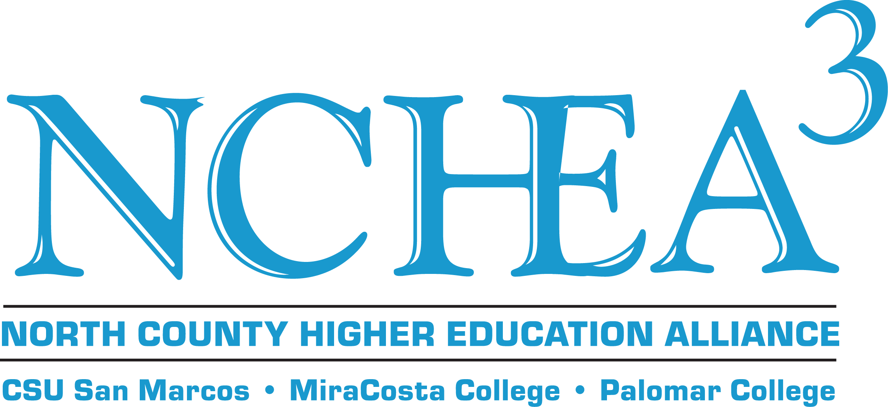

Spring 2015 Mini-Grant Application

The North County Higher Education Alliance was established in 1991 to foster collaboration among college and university educators at CSU San Marcos, MiraCosta College, and Palomar College. Improving and sustaining effective communication and support for faculty, staff, and students, and ensuring seamless transfer are fundamental goals.

Guidelines:
- Applications for mini-grants for amounts from $.01-$500.00 are considered during the academic year; grants are voted on at the next NCHEA Board meeting after the grant application is received; view current meeting dates at http://csusm.edu/nchea (Final submission date for Spring 2015 consideration is Thursday, April 9, 2015 by 5:00 P.M.)
- NCHEA mini-grants may not be used for stipends for grant requestors/collaborative partners.
- If you are a part-time faculty member please let your department chair know you are applying for a grant.
- Retroactive projects cannot be funded; please submit your grant application before your event.
- Grants will be made based on the availability of funds. Activities funded in the Spring 2015 cycle must be completed by May 31, 2016.

Please submit this application by e-mail to Steven Deineh at sdeineh@miracosta.edu.

- Project/Event Title:

- Project/Grant Director:

- Which group are you a member of: Faculty, Staff, or Administration?

- With which institution are you affiliated?

- Telephone:

- Email:

- List the names & email addresses of collaborative partners at the other two institutions:

- Date of event:

- Location of event:

- Amount requested ($.01-$500.00):

- Describe what the NCHEA funds will be used for and provide a detailed, itemized breakdown of estimated expenses.

- Are you seeking funding from other sources? If, so how much and from where?

- Which NCHEA objectives will your fund request meet? Please place a checkmark next to all that apply.

Seek to foster better communication among staff, faculty and students to ensure seamless transfer.
Facilitate meetings of department members among the 3 institutions to discuss instructional services.
Facilitate meetings of department members among the three institutions to discuss student services.
Develop inter-institutional grant proposals and projects.
Increase rates of persistence and transfer among North County students.
Sponsor a yearly retreat.
Sponsor speaker to visit at least two (three preferred) institutions.
Publish a newsletter to publicize cultural events.

- Describe how this event will meet the objectives you selected (in 250 words or less):

- What is the estimated number of attendees (faculty, staff, and students) you expect to have at your event?

- How will you advertise the event at all three campuses?

- Describe how you will advertise NCHEA at this event (in 250 words or less):

- If you receive funding from NCHEA, will you or a collaborative partner present about your grant at a NCHEA event (e.g. Annual Sundowner, Board Meeting, etc.)?

FINAL REPORT

Within two weeks of the completion of the project, a Final Report and all support materials must be submitted to Steven Deineh, the NCHEA Director.

Please email this Final Report (as a Word document, not as a pdf) to Steven Deineh at sdeineh@miracosta.edu and include items 7, 8, and 9 as email attachments. (If hard copies are the only available versions of these items, then please mail in hard copies.) 2.) Additionally, mail a hard copy of the Final Report and all original receipts, W-9 forms, etc. (item #10 on this form) to Steven Deineh, NCHEA Director, MiraCosta College Library (M/S 11), Oceanside, CA 92056. (We are unable to accept faxes or pdf files; original copies of these documents are required, so be sure to save copies for your records.)

- Project Title:

- Project/Grant Director:

- Description of project/objectives (in 250 words or less):

- Description of faculty/staff intercampus collaboration (in 250 words or less):

- Number of faculty, staff, and/or students served (broken down by institution):

- Assessment of project outcome (in 250 words or less):

- Signature list/sign-in sheet for the event – please attach to email
- Flyer or advertisement for the event – please attach to email
- Samples of photos taken at the event – please attach to email
- Original receipts, W-9 forms, etc. (no faxes or pdfs)– please mail hard copies to above address; retain copies of these documents for your own records

